The March CE Primary KS1 Science Quiz
Week 5 – Life Cycles
Email your answers to: nboden@march.w-sussex.sch.uk

1.
Where are you most likely to find a frog?
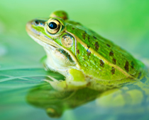
In a field
On a lawn
In a tree
Near a pond
2.
Frogs lay their eggs in ponds. What do we call their eggs?
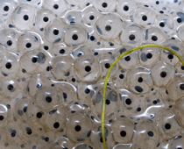
Frogspawn
Hens’ eggs
Duck eggs
Tadpoles
3.
What hatch from the eggs of frogspawn and swim in the pond?
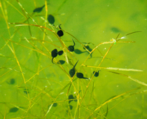
Frogs
Fish
Hens
Tadpoles
4.
Look closely. What has this tadpole grown?
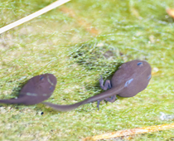
Arms
Legs
Fins
Claws
5.
This tadpole is turning into a froglet. A froglet is a young frog. How many legs has the froglet?
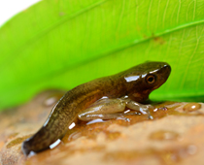
2
4
6
8
6.
When will you find frogspawn and tadpoles?
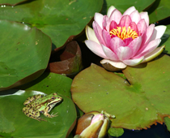
Christmas
Spring
Summer
Autumn
7.
The tadpole grows legs. What does the tadpole lose as it changes into an adult frog?
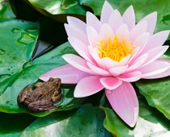
Arms
Tail
Head
Body
8.
Which one of these is an adult?
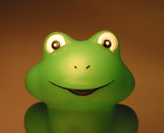
Frogspawn
Tadpole
Froglet
Frog
9.
What do frogs eat?
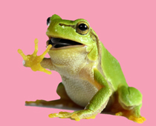
Flies
Leaves
Seeds
Fruit
10.
How do frogs catch their food?
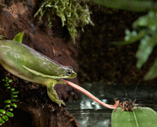
With their legs
With a stick
With their tongues
With their feet

.
Email answers to:nboden@march.w-sussex.sch.uk

