What to do today
IMPORTANT Parent or Carer – Read this page with your child and check that you are happy with what they have to do and any weblinks or use of internet.

If you have a version of Fantastic Mr Fox (book, e-book, audio book or film) it would be great for children to read, listen to or watch the rest of the book.
- Reading Fantastic Mr Fox
- If you haven’t been able to read, watch or listen to the whole book read the summary of events in the story.

- Composition
- Look at the story curve for Fantastic Mr Fox.
- Write your own story along the same lines as Fantastic Mr Fox. Use the story prompts to structure your story which will focus on an animal family and their enemies.

Try the Fun-Time Extras
- Illustrate your story.
- Practise reading your story aloud. (You can see lots of celebrities reading stories on the CBeebies website https://www.bbc.co.uk/iplayer/episodes/b00jdlm2/cbeebies-bedtime-stories and see how they use expression as they read). Read your story aloud via FaceTime, Skype or Zoom to another member of your family. Can they guess which story gave you inspiration?

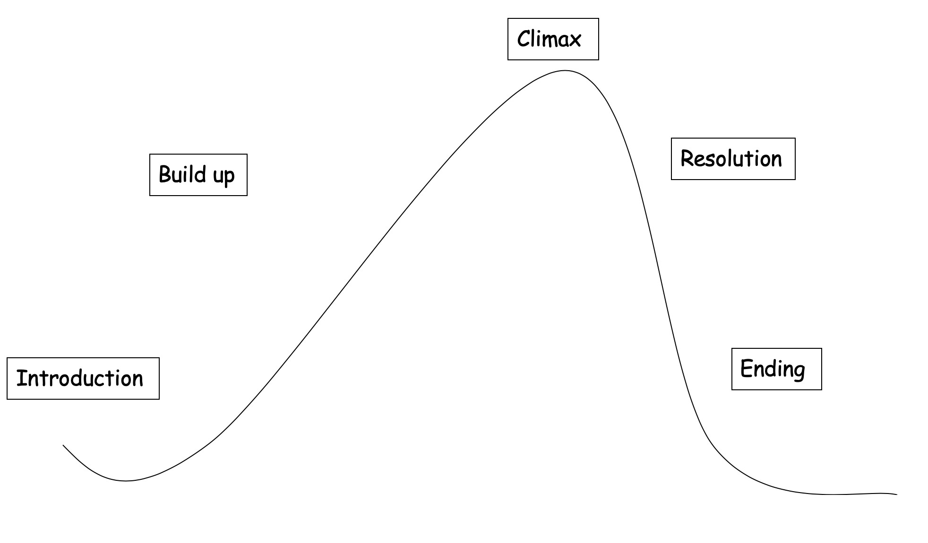
Meet the characters - The farmers are nasty and mean, the Fox family seem nice but do lots of stealing.
Farmers dig down – trying to catch Mr Fox
Caught out, trapped – the family begin to starve
Make a plan… a fantastic plan! Escape.
A big feast… a toast to Mr Fox.

Story writing
- Plan your own story using Fantastic Mr Fox as inspiration.
- Decide on the family of animals you will write about and the setting for your story.
- Draw your own story curve and make notes for each section.
- Think about what might happen in each section of your story.
- Now write your story!

