The March CE Primary KS1 Science Quiz
Week 3 – Lights and Shadows
Email your answers to: nboden@march.w-sussex.sch.uk

1. Sarah is asleep in bed. The light is on. Sarah casts a shadow on the pillow. Sarah’s Mum comes in and quietly turns off the light. What happens to Sarah’s shadow?
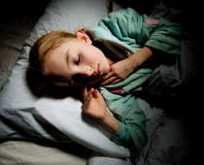
- Sarah’s shadow gets darker
- Sarah’s shadow disappears
- Sarah’s shadow gets bigger
- Sarah’s shadow gets smaller

2. The light is being blocked by Gareth. The light cannot go through Gareth. Gareth is ______.
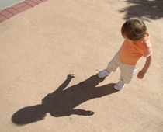
- Transparent
- Elastic
- Plastic
- Opaque

3. There is a shadow on the field. What is up in the air?
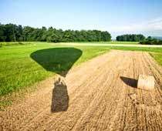
- Bale of straw
- Grass
- Hot air balloon
- Helicopter

4. What is this shadow puppet?
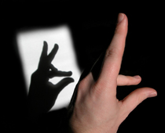
- A rabbit
- A cow
- A sheep
- A fox

5. What do we call lines of sunlight?
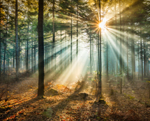
- Shadows
- Rulers
- Rays
- Clouds

6. Look at the picture carefully. What can you see?
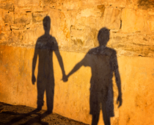
- Two people beside a wall
- The shadows of two people
- One real person and one shadow
- A mirror on the wall

7. This is a picture under a leaf. The frog is casting a shadow. Where is the frog?
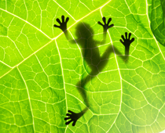
- Under the leaf
- On top of the leaf
- Inside the leaf
- Nowhere near the leaf

9. Gareth is standing looking at his shadow. Which direction is the Sun?
- To the right
- To the left
- Straight above Gareth’s head
- Under Gareth’s feet

9. What do we call lots of rays of light?
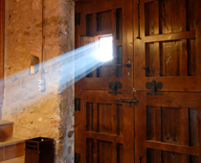
- A shadow
- A wedge
- A door
- A beam

10. Look at this picture. These are shadows of a family in a park. There is a pram, a man and a child. The shadows are:
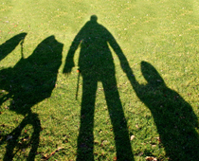
- Longer than the real things
- Shorter than the real things
- Brightly coloured
- Brighter than the grass

Email your answers to:nboden@march.w-sussex.sch.uk

