Level 3 – Level 4

Number
How much?
- While shopping, point out an item costing less than £1.
- Ask your child to work out in their head the cost of 3 items.
- Ask them to guess first.
See how close they come.
- If you see any items labelled, for example, ‘2 for £3.50’, ask them to work out the cost of 1 item for you, and to explain how they got the answer.

Telephone challenges
- Challenge your child to find numbers in the telephone directory where the digits add up to 42.
- Find as many as possible in 10 minutes.
- On another day, see if they can beat their previous total.

Telephone: 01264 738 281

Target 1000
- Roll a dice 6 times.
- Use the six digits to make two three-digit numbers.
- Add the two numbers together.
- How close to 1000 can you get?

Dicey subtractions
- Take turns to roll a dice twice.
- Fill in the missing boxes.
400 - 399
e.g. 4002 – 3994
- Count on from the smaller to the larger number, e.g 3995, 3996, 3997, 3998, 3999, 4000, 4001, 4002.
- You counted on 8, so you score 8 points.
- Keep a running total of your score.
- The first to get 50 or more points wins.

Decimal number plates
- Each choose a car number plate with three digits.
P645 CJM
- Choose two of the digits, e.g. 4 and 6. Make the smallest and largest numbers you can, each with 1 decimal places, e.g. 4.6 and 6.4.
- Now find the difference between the two decimal numbers,
e.g. 6.4 – 4.6 = 1.8.
- Whoever makes the biggest difference scores 10 points.
- The person with the most points wins.
Play the game again, but this time score 10 points for the smallest difference, or 10 points for the biggest total.

Car numbers
- Try reading a car number as a measurement in centimetres, then converting it to metres, e.g. 456cm, which is 4.56m, or 4m and 56cm.
- Try this with car numbers that have zeros in them, e.g. 307cm, which is 3.07m or 3m and 7cm; 370cm, which is 3.7m, or 3m and 70cm. These are harder!

Car numbers 2
- Choose a car number.
- You may add or subtract 10, 20, 30, 40, 50, 60, 70, 80 or 90.
- Try to get as close as possible to 555.
- Who can get closest during a week?

Division

Dicey division
For this game you need a 1–100 board
(a snakes and ladders board will do),
a dice and 20 coins or counters.
- Take turns.
- Choose a two-digit number. Roll a dice. If you roll 1, roll again.
- If your two-digit number divides exactly by the dice number, put a coin on your chosen two-digit number. Otherwise, miss that turn.
- The first to get 10 counters on the board wins.

Multiplication

Times tables
Say together the six times table forwards, then backwards. Ask your child questions, such as:
Nine sixes? How many sixes in 42?
Six times four? Forty-eight divided by six?
Three multiplied by six? Six times what equals sixty?
Repeat with the seven, eight and nine times tables.

Tables
Make a times-table grid like this.

1 | 2 | 3 | 4 | 5 | 6 | 7 | 8 | 9 | 10
2 | 4 | 6 | 8 | 10 | 12 | 14 | 16 | 18 | 20
3 | 6 | 9 | 12 | 15 | 18 | 21 | 24 | 27 | 30
4 | 8 | 12 | 16 | 20 | 24 | 28 | 32 | 36 | 40
5 | 10 | 15 | 20 | 25 | 30 | 35 | 40 | 45 | 50
6 | 12 | 18 | 24 | 30 | 36 | 42 | 48 | 54 | 60
7 | 14 | 21 | 28 | 35 | 42 | 49 | 56 | 63 | 70
8 | 16 | 24 | 32 | 40 | 48 | 56 | 64 | 72 | 80
9 | 18 | 27 | 36 | 45 | 54 | 63 | 72 | 81 | 90
10 | 20 | 30 | 40 | 50 | 60 | 70 | 80 | 90 | 100

- Shade in all the tables facts that your child knows, probably the 1s, 2s, 3s, 4s, 5s and 10s.
- Some facts appear twice, e.g. 7 x 3 and 3 x 7, so cross out one
of each.
- Are you surprised how few facts are left?
- There might only be 10 facts to learn. So take one fact a day and make up a silly rhyme together to help your child to learn it,
e.g. nine sevens are sixty-three, let's have lots of chips for tea!

Finding areas and perimeters

Perimeter = distance around the edge of a shape
Area of a rectangle = length x breadth (width)

- Collect 5 or 6 used envelopes of different sizes.
- Ask your child to estimate the perimeter of each one to the nearest centimetre. Write the estimate on the back.
- Now measure. Write the estimate next to the measurement.
- How close did your child get?
- Now estimate then work out the area of each envelope.
- Were perimeters or areas easier to estimate? Why?

You could do something similar using an old newspaper, e.g.
- Work out which page has the biggest area used for photographs.
- Choose a page and work out the total area of news stories or adverts on that page.

Handling data

Get a range of items out of your kitchen cupboard and sort by two categories. Draw two over lapping circles on a piece of paper as below:

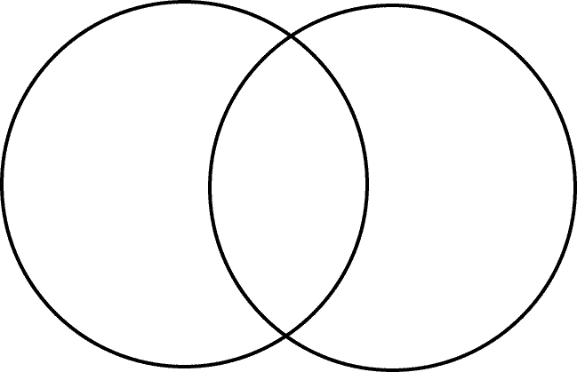

Label each circle with one of your groups. Are there any things that do not fit these categories? Place these outside the circles. Are there any items which are in both groups? Put these where the circles overlap. Then put the other items inside the appropriate circle.

Repeat with different categories.

