Year 3 Home Learning
Week of 18th May 2020

Spellings
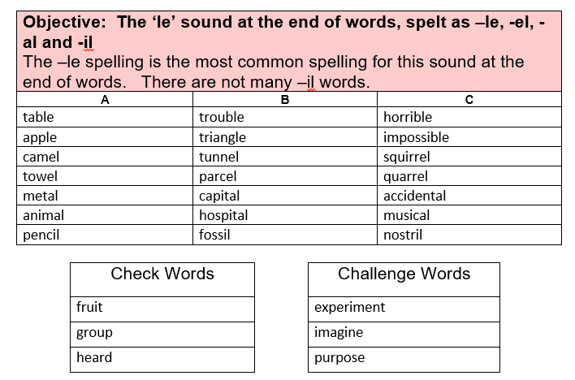
Maths
White Rose Home Learning: https://whiterosemaths.com/homelearning/year-3/

White Rose Home Learning Summer Term - Week 3 (w/c 4th May)
Activity 1
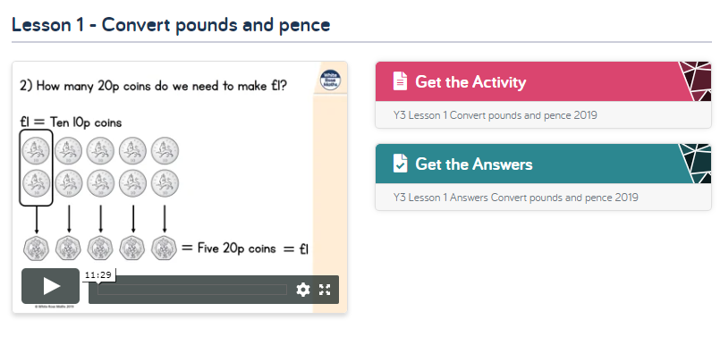

Activity 2
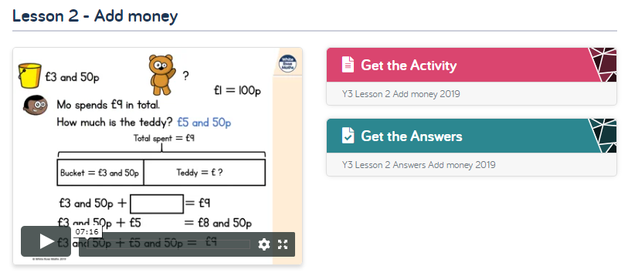
Activity 3
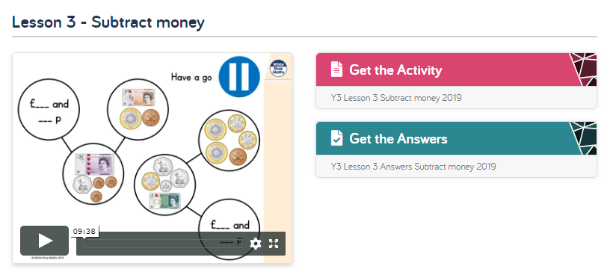
Activity 4
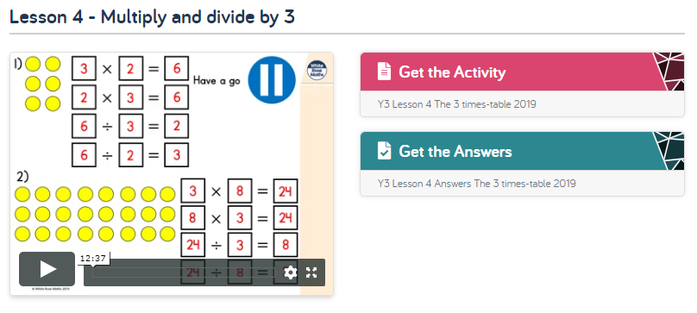

Activity 5
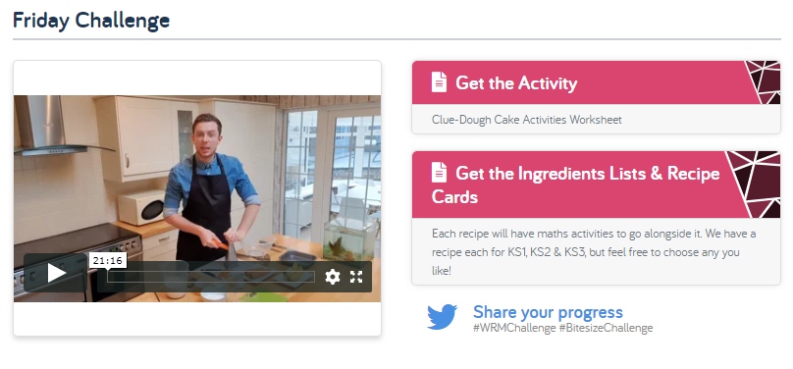
White Rose Home Learning Summer Term - Week 3 (w/c 11th May) https://whiterosemaths.com/homelearning/year-3/

Worksheets emailed out as attachments

Activity 1
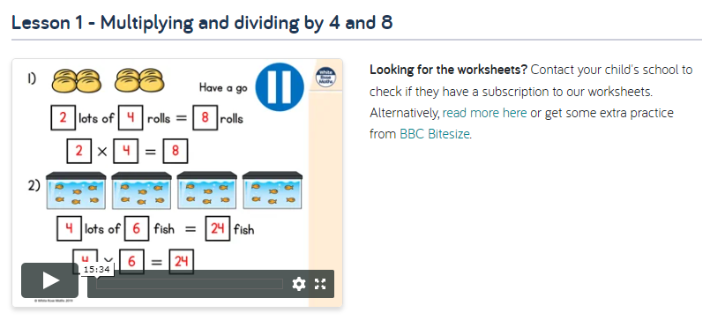

Activity 2
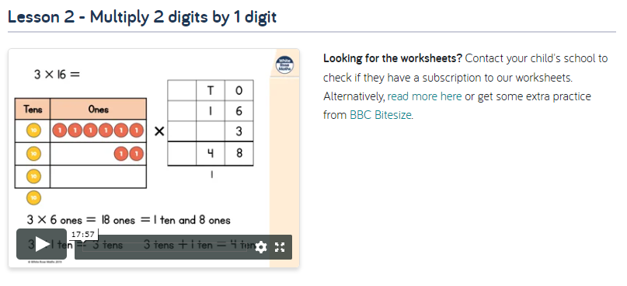

Activity 3
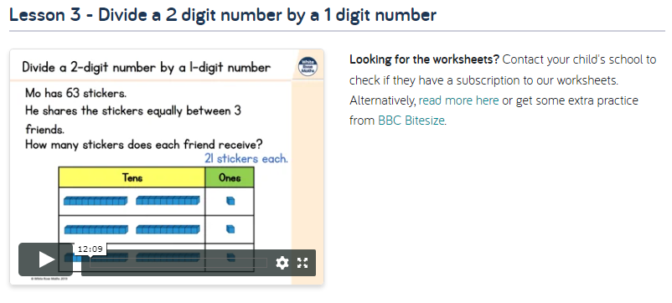

Activity 4
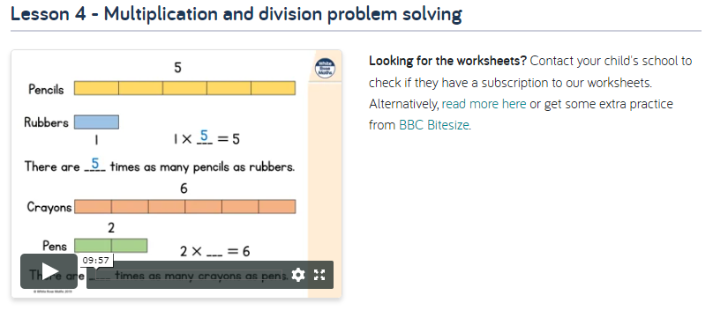
Activity 5
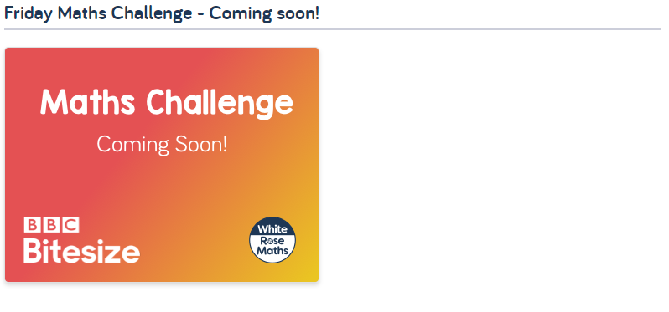

White Rose Home Learning Summer Term - Week 3 (w/c 18th May) https://whiterosemaths.com/homelearning/year-3/
Worksheets emailed out as attachments

There are two options for this week, option number one is to continue to work on fractions and moving into decimals, the alternative options id adding and subtracting two and three digit numbers. I will email out both sets of worksheets for you, feel free to pick and choose what to do this week.

Option 1 – fractions and decimals | Option 2- alternative plan – adding and subtracting two and three digit numbers
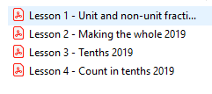 | 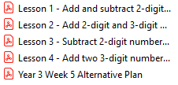

Option 1

Activity 1
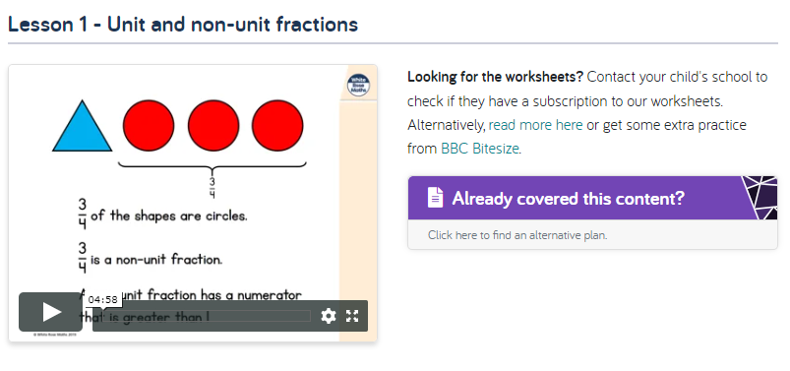

Activity 2
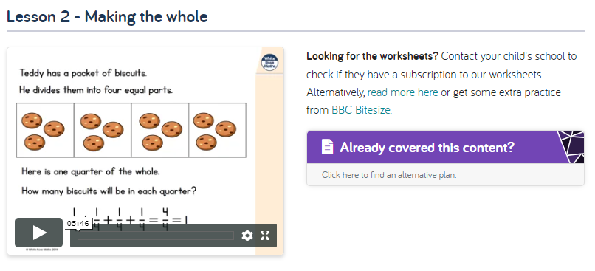

Activity 3
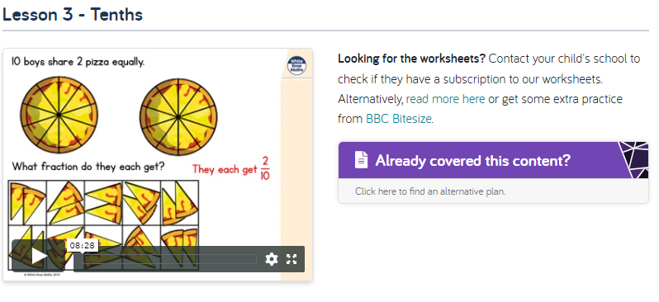
Activity 4
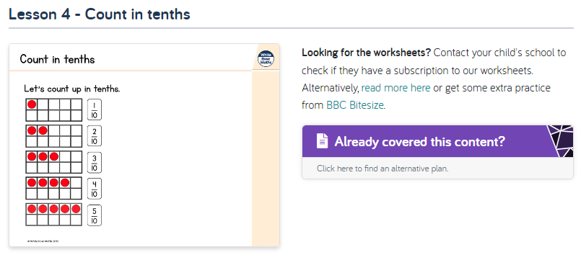
Activity 5
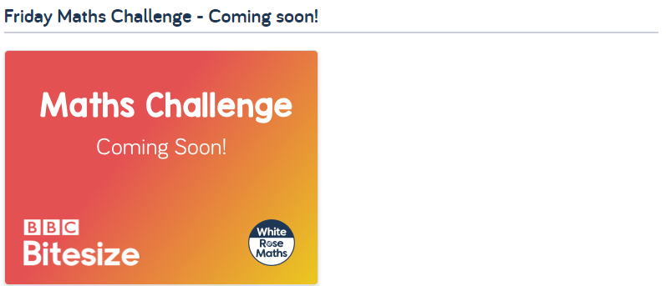

Option 2
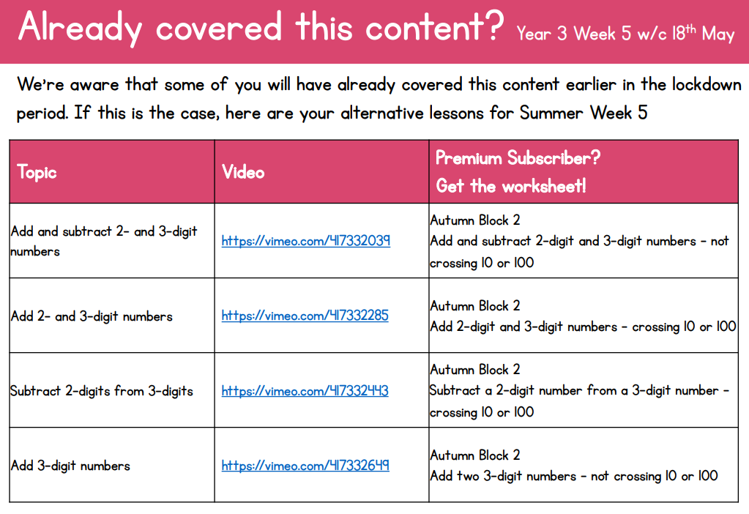

English
Hamilton Trust – Year 3 English – Week 5
https://www.hamilton-trust.org.uk/blog/learning-home-packs/
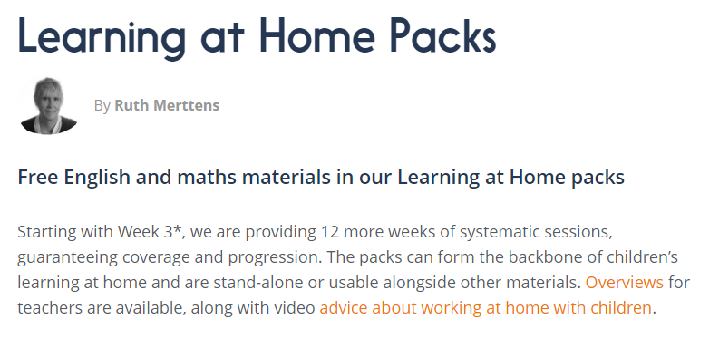
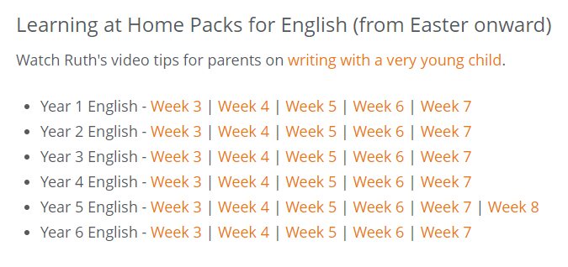

Topic Ideas
You can use our topic homework grid to complete topic or you could create some work or even a topic all of your own choosing. Just have fun and keep safe.
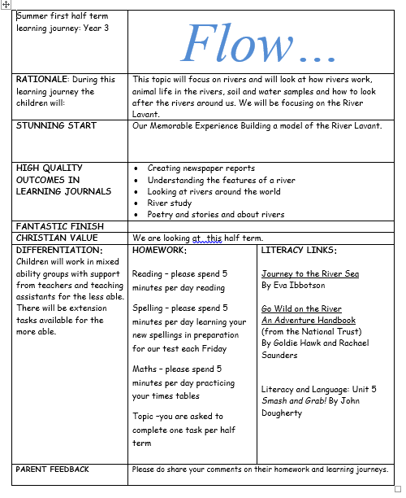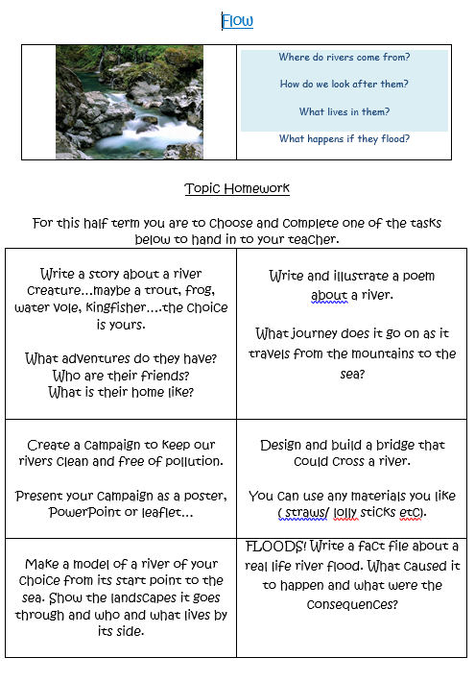

Here is a fun science experiment you can try…
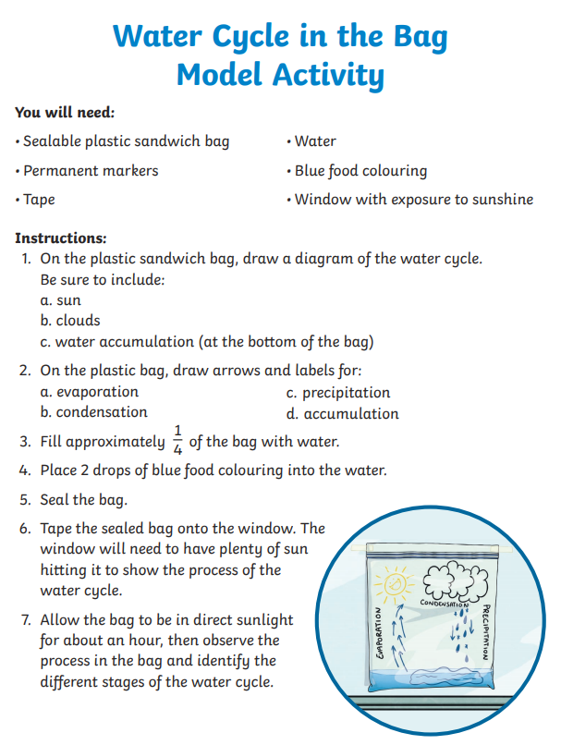

Outdoor Art ideas…
