Year 3 Home Learning
Week of 8th June 2020

Spellings
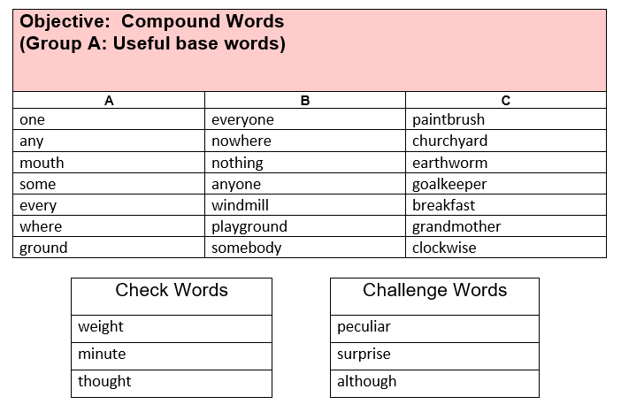

Maths
White Rose: https://whiterosemaths.com/homelearning/year-3/

White Rose Home Learning Summer Term – Week 7 (w/c 8th June)

Worksheets emailed out as attachments

Activity 1
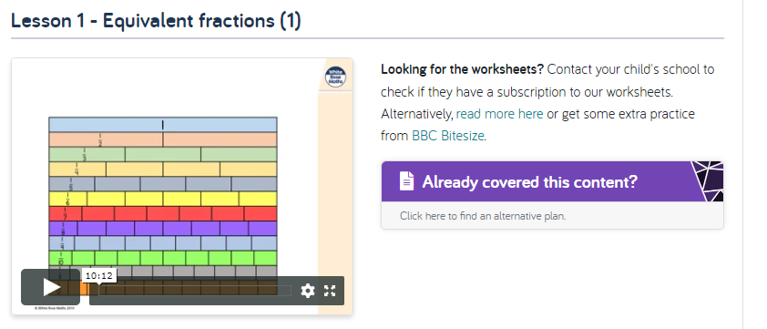

Activity 2
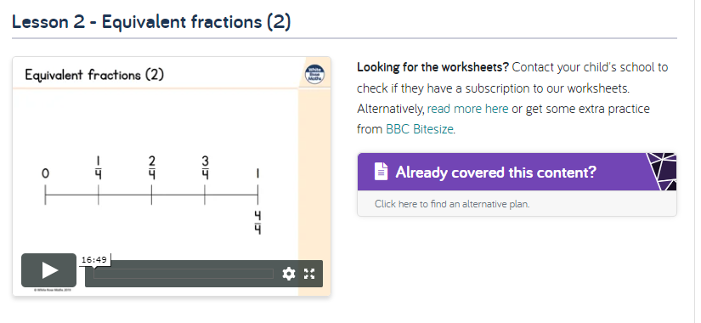
Activity 3
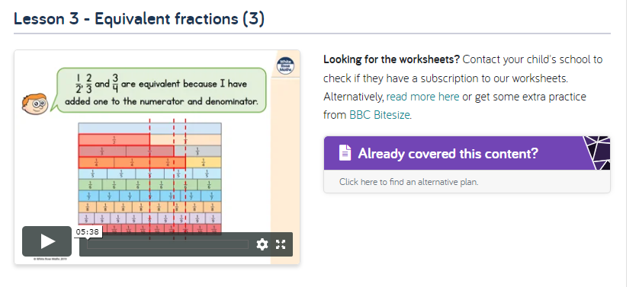

Activity 4
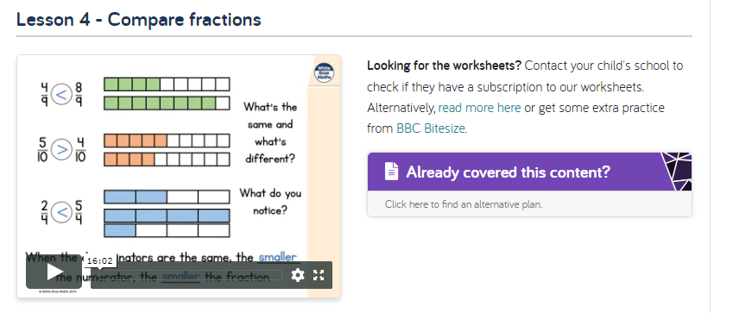

Activity 5
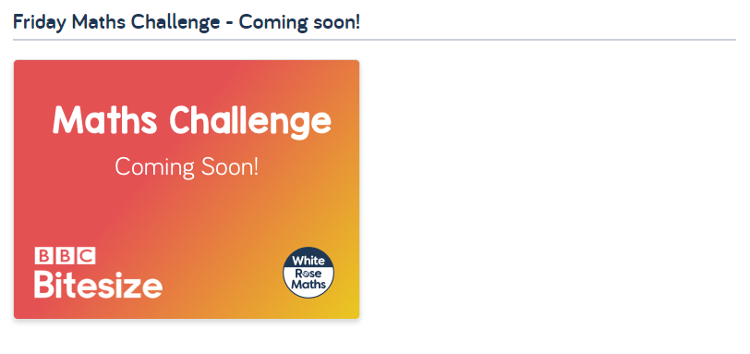

English
Hamilton Trust – Year 3 English – Week 7
https://www.hamilton-trust.org.uk/blog/learning-home-packs/
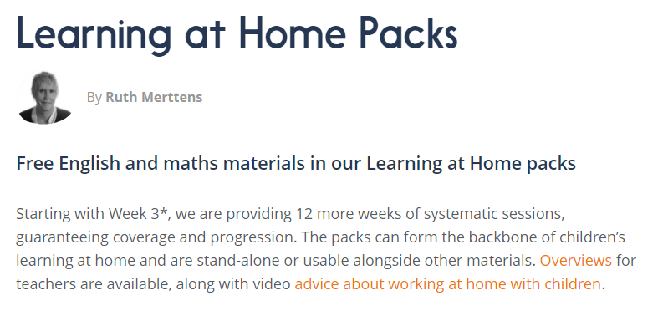
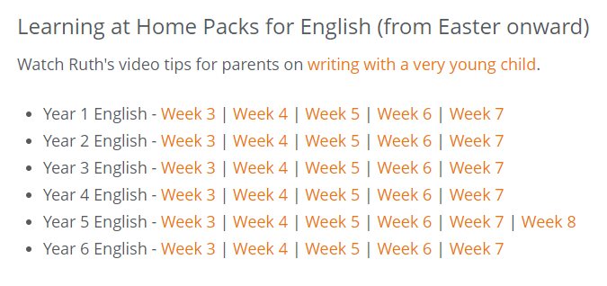

Our new topic is…

Gods and Mortals

For home learning you may choose an activity from our homework grid or you might like to complete some of the following activities that we will completing in class this week.

Geography Activity

Describe and compare different features of human and physical geography of a place, offering explanations for the locations for some of these features.

Locate Greece on a globe or world map, identifying the continent on which it lies and which countries surround it. Look at pictures and photographs of the Greek landscape, making judgements about physical aspects of its geography including weather, terrain and settlements. Plot the journey made by Icarus and Daedalus from the island of Crete to Sicily. Children could use satellite mapping tools to plot their route, estimating the distance travelled and how long the journey might have taken.

History Activity

Choose the most important source material for a task, showing awareness of a range of sources.

Use a range of historical source materials including books, artefacts, images and information books to investigate the everyday life of the ancient Greeks, contrasting the lives of the rich and poor. Record their findings using drawings, labels, notes, ICT and written work. Children could explore different aspects of everyday life. Homes, children, food and warfare would all make interesting research topics.

DT Activity

Make realistic plans identifying processes, equipment and materials needed.

Imagine they are Daedalus, the master craftsman. Invent a pair of wings for Icarus – ones that would withstand the sun’s heat! Experiment with design options, labelling moving parts. Identify which materials they will use to make their designs and construct the finished wings using a variety of techniques. Explain how they will test their wings. Children could write instructions to explain to others how to make and test their wings. Do any of the designs work?

