Year 3 Home Learning
Week of 15th June 2020

Spellings
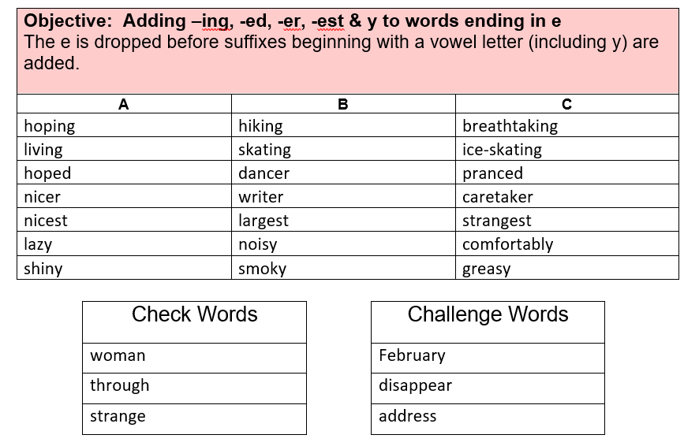

Maths
White Rose: https://whiterosemaths.com/homelearning/year-3/

White Rose Home Learning Summer Term – Week (w/c 15th June)

Worksheets emailed out as attachments

Activity 1
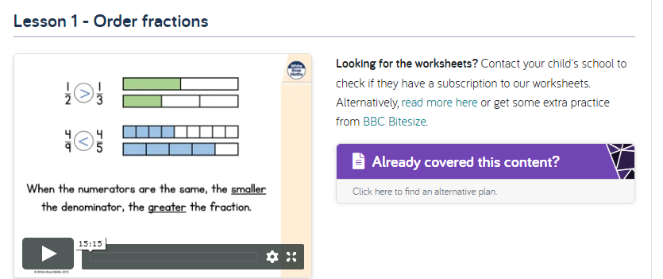

Activity 2
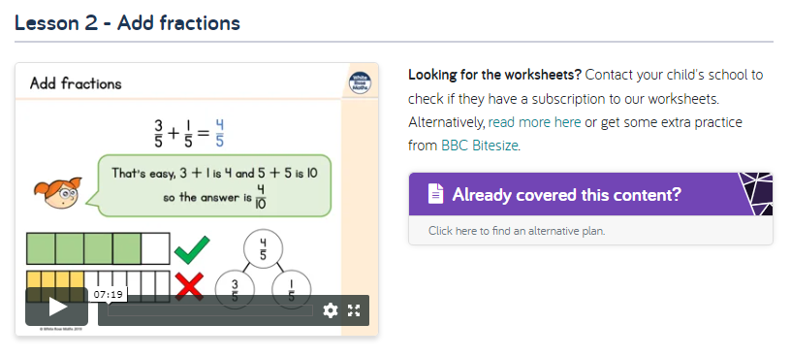
Activity 3
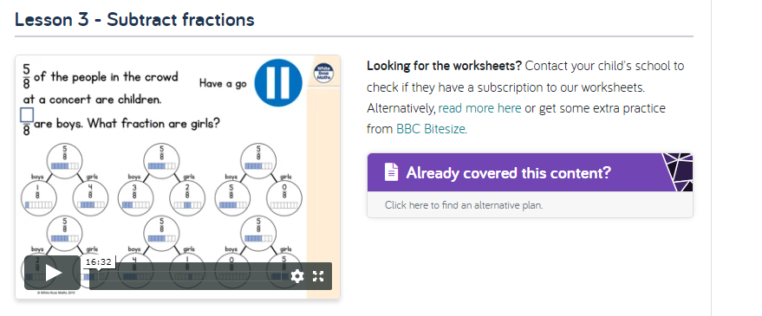

Activity 4
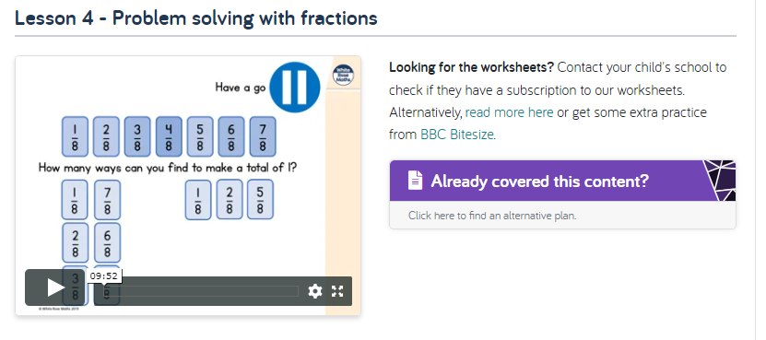

Activity 5

English
Hamilton Trust – Year 3 English – Week 8
https://www.hamilton-trust.org.uk/blog/learning-home-packs/
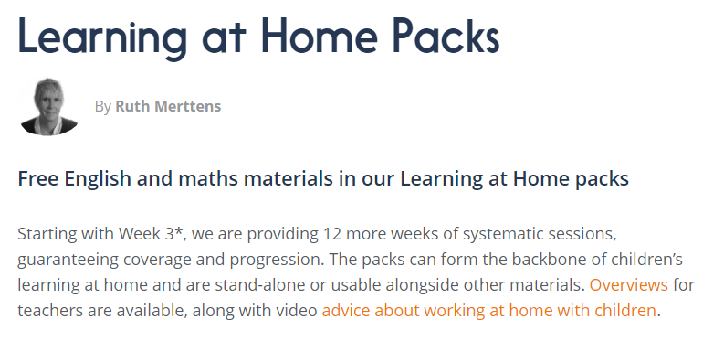
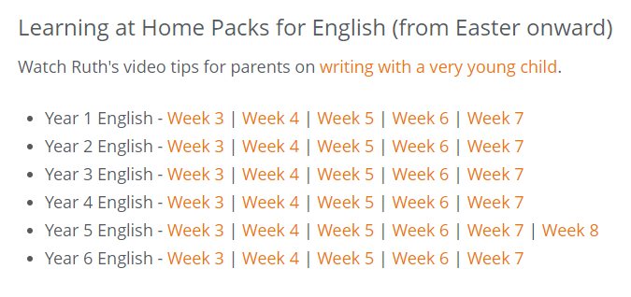

Our new topic is…

Gods and Mortals

For home learning you may choose an activity from our homework grid or you might like to complete some of the following activities that we will completing in class this week.

Art Activity – Ancient Greek Temples
Research Ancient Greek temples, I have attached a PowerPoint you can use, and then design and make your own temple. Here is an idea: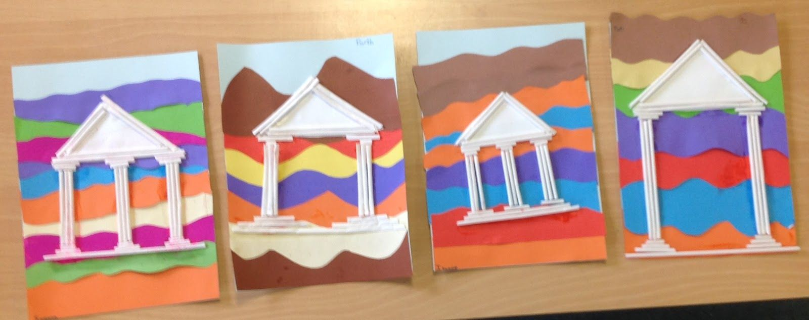

History Activity – Battle of Marathon
Choose the most important source material for a task, showing awareness of a range of sources. Listen to the story of the Battle of Marathon and the heroism of the Greek messenger, Pheidippides. Consider how this legend has continued into modern life. How many ‘marathons’ are run worldwide today? Children could find out about some more contemporary long distance athletes such as Haile Gebrselassie, Paula Radcliffe and Mo Farah.

DT Activity – Trojan Horse
Plan which materials will be needed for a task and explain why. Construct their own decoy vessel using recycled materials. Use old milk cartons and soft drink bottles for the body, cutting windows or trap doors for the soldiers to climb in and out. Plan their ideas in a sketch book, labelling each part of their design. Then construct their design, attaching it to a wheel-based axle to enable it to be moved inside the wooden gates. Decorate their vessel using paint, paper, felt, card and other materials. Children could work in small groups to make fewer horses but on a bigger scale, using materials such as large card tubes, bigger bottles and containers. Use small world figures to place inside the horse! Or how about one huge horse that hides everybody?

