Class 1 Easter Letter

Dear Parents of Class 1,
I hope you are all doing well and keeping safe at this uncertain time. I have received some wonderful emails over the past few weeks from lots of you with pictures of home learning and messages of support for which I am very grateful. I am enjoying seeing what the children are completing at home so please do keep sending me anything you can if you can. Although it may not feel like it, it is now the Easter holidays so I have attached a booklet that the children could do with some Easter maths based activities as well as some craft ideas that you could do. In terms of writing over the Easter period children could write letters to people or diary entries on what they are doing each day in order to practice those skills.
Thank you,
Miss Grounds.

Easter Egg Rocks: Children could go into the garden and look for the right size rock and paint, colour and decorate like an Easter egg. If not a rock an egg could be hard boiled and used instead (but I understand the need to want to ration these).

Easter Cupcakes: The children could use their knowledge of weight that they learnt about last week in this baking activity. I have attached an easy recipe in which you could follow in order to make some Easter cupcakes for the family. http://www.foodnetwork.co.uk/recipes/easter-cupcakes.html
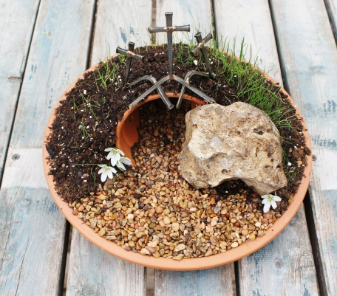
Easter Gardens: As another activity the children could make an Easter garden. I have attached a website which explains how to design and make one of these, could be done as a Good Friday activity.
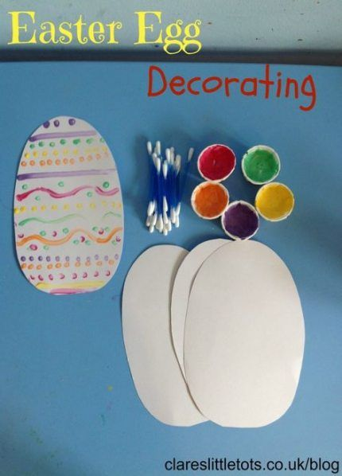
https://www.twinkl.co.uk/resource/us-re-090-make-an-easter-garden-activity

Design your own Easter egg: using cotton wool buds children could design their own Easter egg in whichever way they choose.

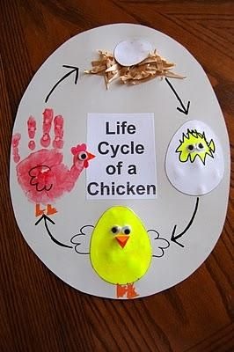
Life Cycle of a Chicken: Children could use a paper plate or a piece of round paper to illustrate the life of a chicken and how it carries on round in a cycle.
As always there are resources for Easter on Twinkl and I am available for emails also.

