What to do today
IMPORTANT Parent or Carer – Read this page with your child and check that you are happy with what they have to do and any weblinks or use of internet.

If you have a version of Fantastic Mr Fox (book, e-book, audio book or film) it would be great for children to read, listen to or watch the rest of the book.
- Reading Fantastic Mr Fox
- Read the summary of events in the story so far.
- Read chapter 16 which describes what happens in Bean’s cider cellar.

- Verbs – Present Perfect Form
- Watch the presentation on the PowerPoint OR read through the Learning Reminder Verbs - Present Perfect Form.
- Look back at chapter 16 and find some past tense verbs (hint – look for doing words with –ed endings). Practise changing them into the present perfect form by adding has or have.
- Complete the present perfect forms activities. Start with activity one, challenge yourself to see if you can do all three!

Try the Fun-Time Extras
- Roald Dahl had a very interesting life. Did you know he was a fighter pilot during the second world war? See if you can find out more information and create a factsheet about him.

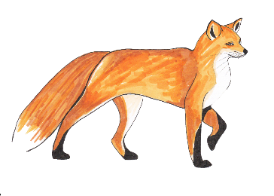
Chapter 16 The Woman
‘Quick!’ said Mr Fox. ‘Hide!’ He and Badger and the Smallest Fox jumped up on to a shelf and crouched behind a big row of cider jars. Peering around the jars, they saw a huge woman coming down into the cellar. At the foot of the steps, the woman paused, looking to right and left. Then she turned and headed straight for the place where Mr Fox and Badger and the Smallest Fox were hiding. She stopped right in front of them. The only thing between her and them was a row of cider jars. She was so close, Mr Fox could hear the sound of her breathing. Peeping through the crack between two bottles, he noticed that she carried a big rolling-pin in one hand.
‘How many will he want this time, Mrs Bean?’ the woman shouted. And from the top of the steps the other voice called back, ‘Bring up two or three jars.’
‘He drank four yesterday, Mrs Bean.’
‘Yes, but he won’t want that many today because he’s not going to be up there more than a few hours longer. He says the fox is bound to make a run for it this morning. It can’t possible stay down that hole another day without food.’
The woman in the cellar reached out and lifted a jar of cider from the shelf. The jar she took was next but one to the jar behind which Mr Fox was crouching.
‘I’ll be glad when the rotten brute is killed and strung up on the front porch,’ she called out. ‘And by the way, Mrs Bean, your husband promised I could have the tail as a souvenir.’
‘The tail’s been shot to pieces,’ said the voice from upstairs. ‘Didn’t you know that?’
‘You mean it’s ruined?’
‘Of course it’s ruined. They shot the tail but missed the fox.’
‘Oh heck!’ said the big woman. ‘I did so want that tail!’
‘You can have the head instead, Mabel. You can get it stuffed and hang it on your bedroom wall. Hurry up now with that cider!’
‘Yes. Ma’am, I’m coming,’ said the big woman, and she took down a second jar from the shelf.
If she takes one more, she’ll see us, thought Mr Fox. He could feel the Smallest Fox’s body pressed tightly against his own, quivering with excitement.
‘Will two be enough, Mrs Bean, or shall I take three?’
‘My goodness, Mabel, I don’t care so long as you get a move on!’
‘Then two it is,’ said the huge woman, speaking to herself now. ‘He drinks too much anyway.’
Carrying a jar in each hand and with the rolling-pin tucked under one arm, she walked away across the cellar. At the foot of the steps she paused and looked around, sniffing the air. ‘There’s rats down here again, Mrs Bean. I can smell ‘em.’
‘Then poison them, woman, poison them! You know where the poison’s kept.’
‘Yes, Ma’am,’ Mabel said. She climbed slowly out of sight up the steps. The door slammed.
‘Quick!’ said Mr Fox. ‘Grab a jar each and run for it!’
Rat stood on his high shelf and shrieked. ‘What did I tell you! You nearly got nabbed, didn’t you? You nearly gave the game away! You keep out of here from now on! I don’t want you around! This is my place!’
‘You,’ said Mr Fox, ‘are going to be poisoned.’
‘Poppycock!’ said Rat. ‘I sit up here and watch her putting the stuff down. She’ll never get me.’
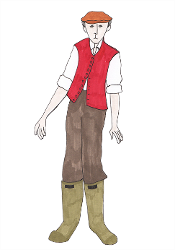
Mr Fox and Badger and the Smallest Fox ran across the cellar clutching a gallon jar each. ‘Goodbye, Rat!’ they called out as they disappeared through the hole in the wall. ‘Thanks for the lovely cider!’
‘Thieves!’ shrieked Rat. ‘Robbers! Bandits! Burglars!’
Underline as many verbs as you can find in this chapter.

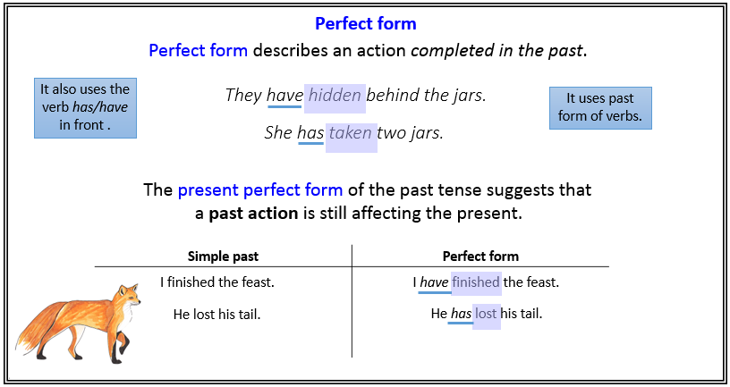
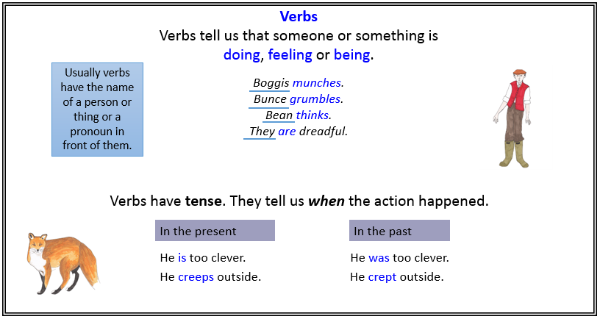
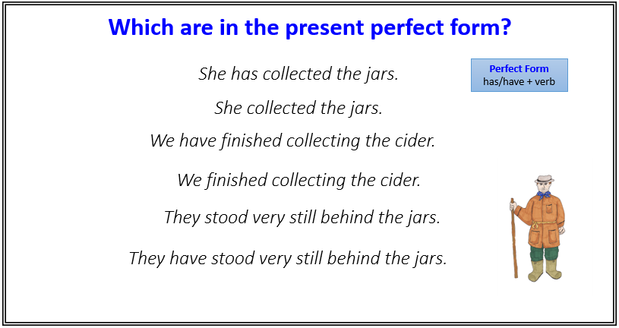
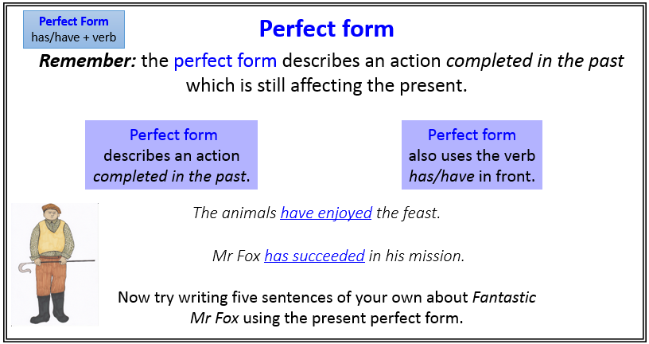
Activity 1: Sentences to sort
Cut out the sentences and sort them into two groups: simple past tense and present perfect tense. Use the learning reminder cards to help you.
She has stopped right in front of them. | They have shot the tail but have missed the fox.
They have hidden behind the jars. | She walked away across the cellar.
The woman shouted to Mrs Boggis. | They have scampered across the cellar floor.
She has brought a rolling pin with her. | She hesitated at the third jar.
The little fox has held his breath. | Mr Fox’s whiskers twitched.

Activity 2: Sentence pairs.
Present Perfect Form
has/have + verb
Draw a line to match the sentences and then underline the present perfect form
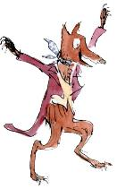
Mr Fox put the last brick back in place. | Badger has raised his glass.
They grabbed their jars of cider. | Mrs Fox has hugged the smallest fox.
Mrs Fox hugged the smallest fox. | The animals have attacked the succulent food.
The animals attacked the succulent food. | Mr Fox has put the last brick back in place.
Badger raised his glass. | They have grabbed their jars of cider.

Activity 2: Sentence pairs - Answers
Present Perfect Form
has/have + verb
Draw a line to match the sentences and then underline the present perfect form

Mr Fox put the last brick back in place. | Badger has raised his glass.
They grabbed their jars of cider. | Mrs Fox has hugged the smallest fox.
Mrs Fox hugged the smallest fox. | The animals have attacked the succulent food.
The animals attacked the succulent food. | Mr Fox has put the last brick back in place.
Badger raised his glass. | They have grabbed their jars of cider.

Activity 3: Present perfect forms: cloze

Can you insert the correct verbs to complete these in the present perfect form?

They __________________ in the tunnel. (pause)
Badger___________________ his glass. (raise)
Mrs Fox __________________the smallest fox. (hug)
The animals __________________ the succulent food. (attack)
Mr Fox __________________ the last brick back in place. (put)
They ___________________ their jars of cider. (grab)
They ___________________down the tunnel. (fly)
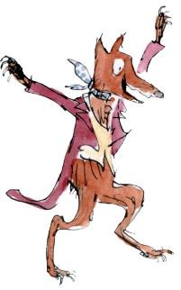
The animals ________________ to eat. (begin)

Activity 3: Present perfect forms: cloze - Answers

Can you insert the correct verbs to complete these in the present perfect form?

They have paused in the tunnel. (pause)
Badger has raised his glass. (raise)
Mrs Fox has hugged the smallest fox. (hug)
The animals have attacked the succulent food. (attack)
Mr Fox has put the last brick back in place. (put)
They have grabbed their jars of cider. (grab)
They have flown down the tunnel. (fly)
The animals have begun to eat. (begin)

