What to do today
IMPORTANT Parent or Carer – Read this page with your child and check that you are happy with what they have to do and any weblinks or use of internet.

- Prepositions and sequencing instructions
- Read the learning reminders about prepositions (these are the same as yesterday – just included here for reference).
- Look at the two pages of Cabbage Cards. Together they make up a set of instructions for making cabbage dye but the main sentences and prepositions have become separated and muddled.
- Cut out the cards and match the main sentences with the correct prepositional phrases.
- Order the instructions correctly and stick them on a piece of paper.
- Challenge yourself to identify what sort of preposition is being used in each sentence (time, place or cause), you could underline each type in a different colour. Can you suggest a possible alternative for the prepositions?

Now work with a grown-up to check the answers.
Discuss any answers which you didn’t quite get. Can you see what went wrong?

Try the Fun-Time Extras
- Write your own set of instructions for something – it could be making a Lego model, drawing a particular picture, planting a seed. Try to include a preposition for each instruction. You could type your instructions up on the computer and add pictures to illustrate each step.
- Try playing ‘Simon Says’ with other family members – the challenge is to include a preposition in each instruction, e.g. ‘Simon says put your hand under your foot’.

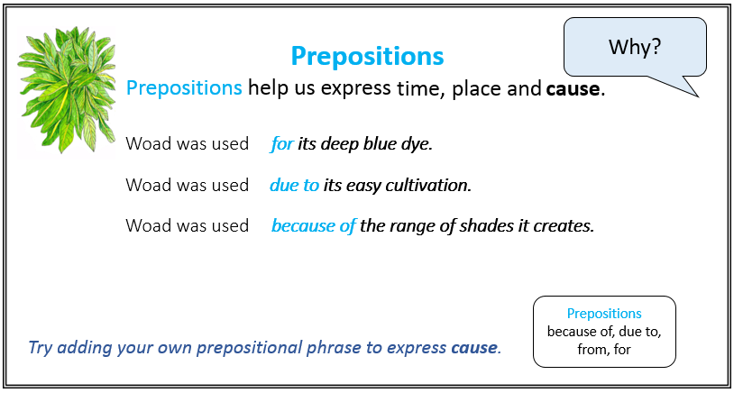
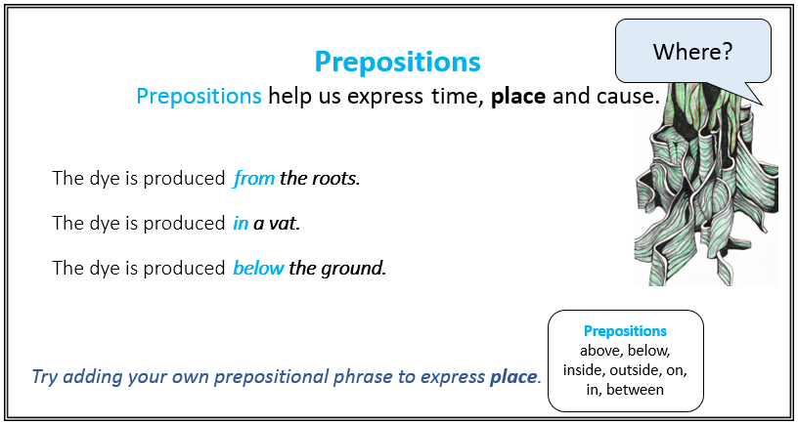
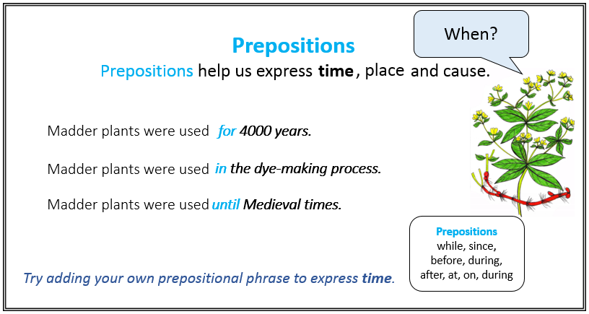
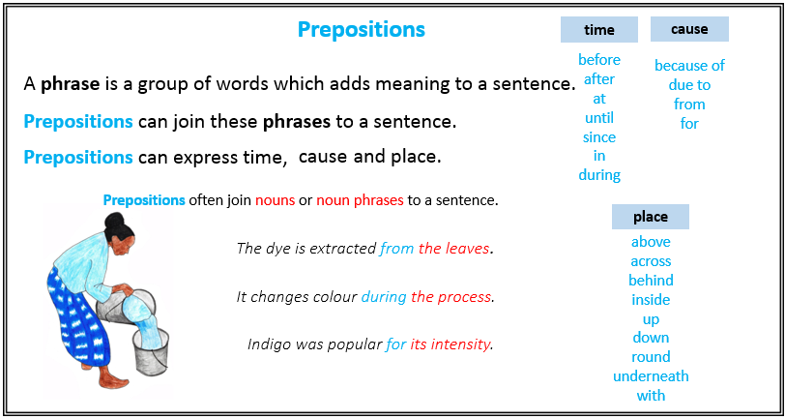
Cabbage Cards (main sentence)
Chop the cabbage | the liquid will be colourful.
Put the chopped cabbage | Place the cabbage liquid
Add baking soda | Leave your cloth
Hang your cloth | rinse any surplus dye.
Boil the cabbage pieces | Place your chosen material
Use disposable gloves | Add vinegar

Cabbage Cards (prepositional phrases)
After 4-8 hours of boiling, | in the dye.
for a pink dye. | in a large pot.
for at least 24 hours. | for 4-8 hours.
from a washing line. | After 24 hours,
for a blue dye. | on a chopping board.
due to the strong pigment. | in a sieve.

ANSWERS Cabbage Cards: instructions in order

- Chop the cabbage on a chopping board. (place)

- Put the chopped cabbage in a large pot. (place)

- Boil the cabbage pieces for 4-8 hours. (time)

- After 4-8 hours of boiling, the liquid will be colourful. (time)

- Use disposable gloves due to the strong pigment. (cause)

- Place the cabbage liquid in a sieve. (place)

- Add vinegar for a pink dye. (cause)

- Add baking soda for a blue dye. (cause)

- Place your chosen material in the dye. (place)

- Leave your cloth for at least 24 hours. (time)

- After 24 hours, rinse any surplus dye. (time)

- Hang your cloth from a washing line. (place)

