What to do today
IMPORTANT Parent or Carer – Read this page with your child and check that you are happy with what they have to do and any weblinks or use of internet.

1. Complete a Crosspoints puzzle
- Read Crosspoints. Fill in the grid with words and then check your score.
- Use the other Crosspoint Grids yourself to try to beat your score OR challenge someone else to play the game and see how they do.

2. Complete a Crossword
- Complete the Minibeast Crossword. Read the clues and write your answers in the crossword grid.
- Choose either the Pet Crossword or the Transport Crossword and complete it.
You could challenge yourself to complete both!

Well done! You can check your answers at the end of this pack. You can find more crosswords to solve at this website:

https://lovattspuzzles.com/kids/childrens-online-puzzles/

3. Make up your Crossword
- Either use the Crossword Template or this website to make up your own crossword:
http://puzzlemaker.discoveryeducation.com/CrissCrossSetupForm.asp
- Choose a theme. Choose words to fit. Make up clues that will lead to these words. Look at the example done by Owl to see how it works!
- Try your crossword out on someone else. How well did they do?

Crosspoints

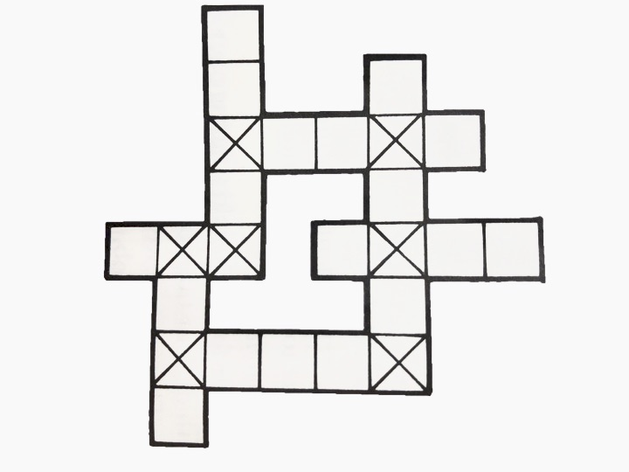
Fill in this grid with words of your choice. You gain points for certain letters. Different letters get different scores. A letter which falls on a ‘cross’ square is counted twice. How high a score can you get?
Letter scores Example
A-1 | N-2 |  | 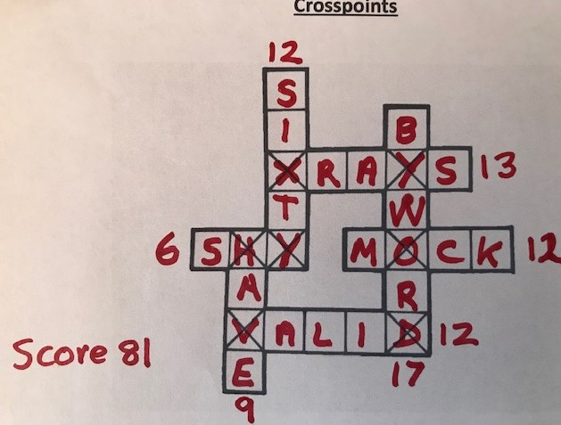
B-4 | O-2
C-3 | P-4
D-2 | Q-6
E-0 | R-2
F-3 | S-1
G-4 | T-1
H-2 | U-2
I-I | V-5
J-5 | W-4
K-4 | X-6
L-3 | Y-3
M-3 | Z-6

Crosspoint Grids

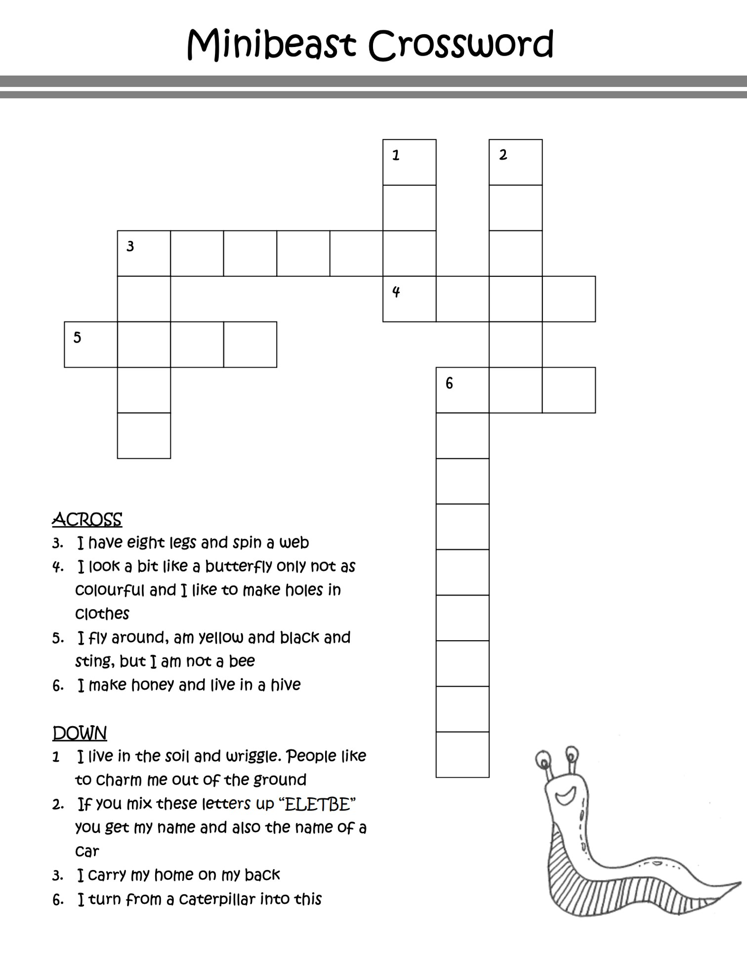

from www.kidspuzzlesandgames.co.uk

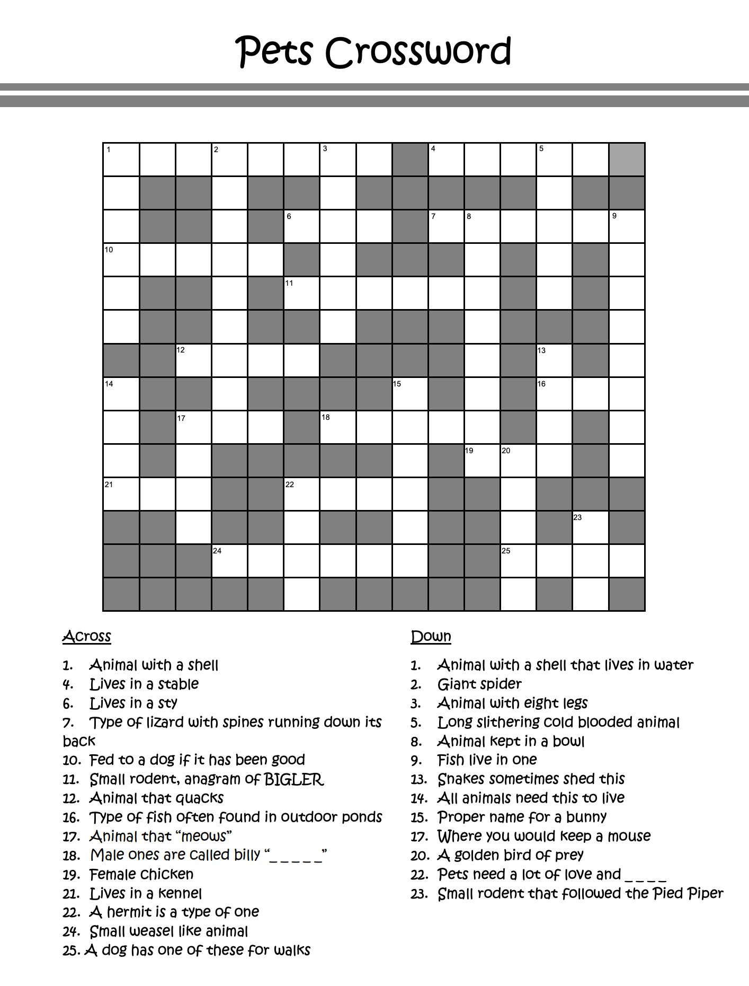
from www.kidspuzzlesandgames.co.uk

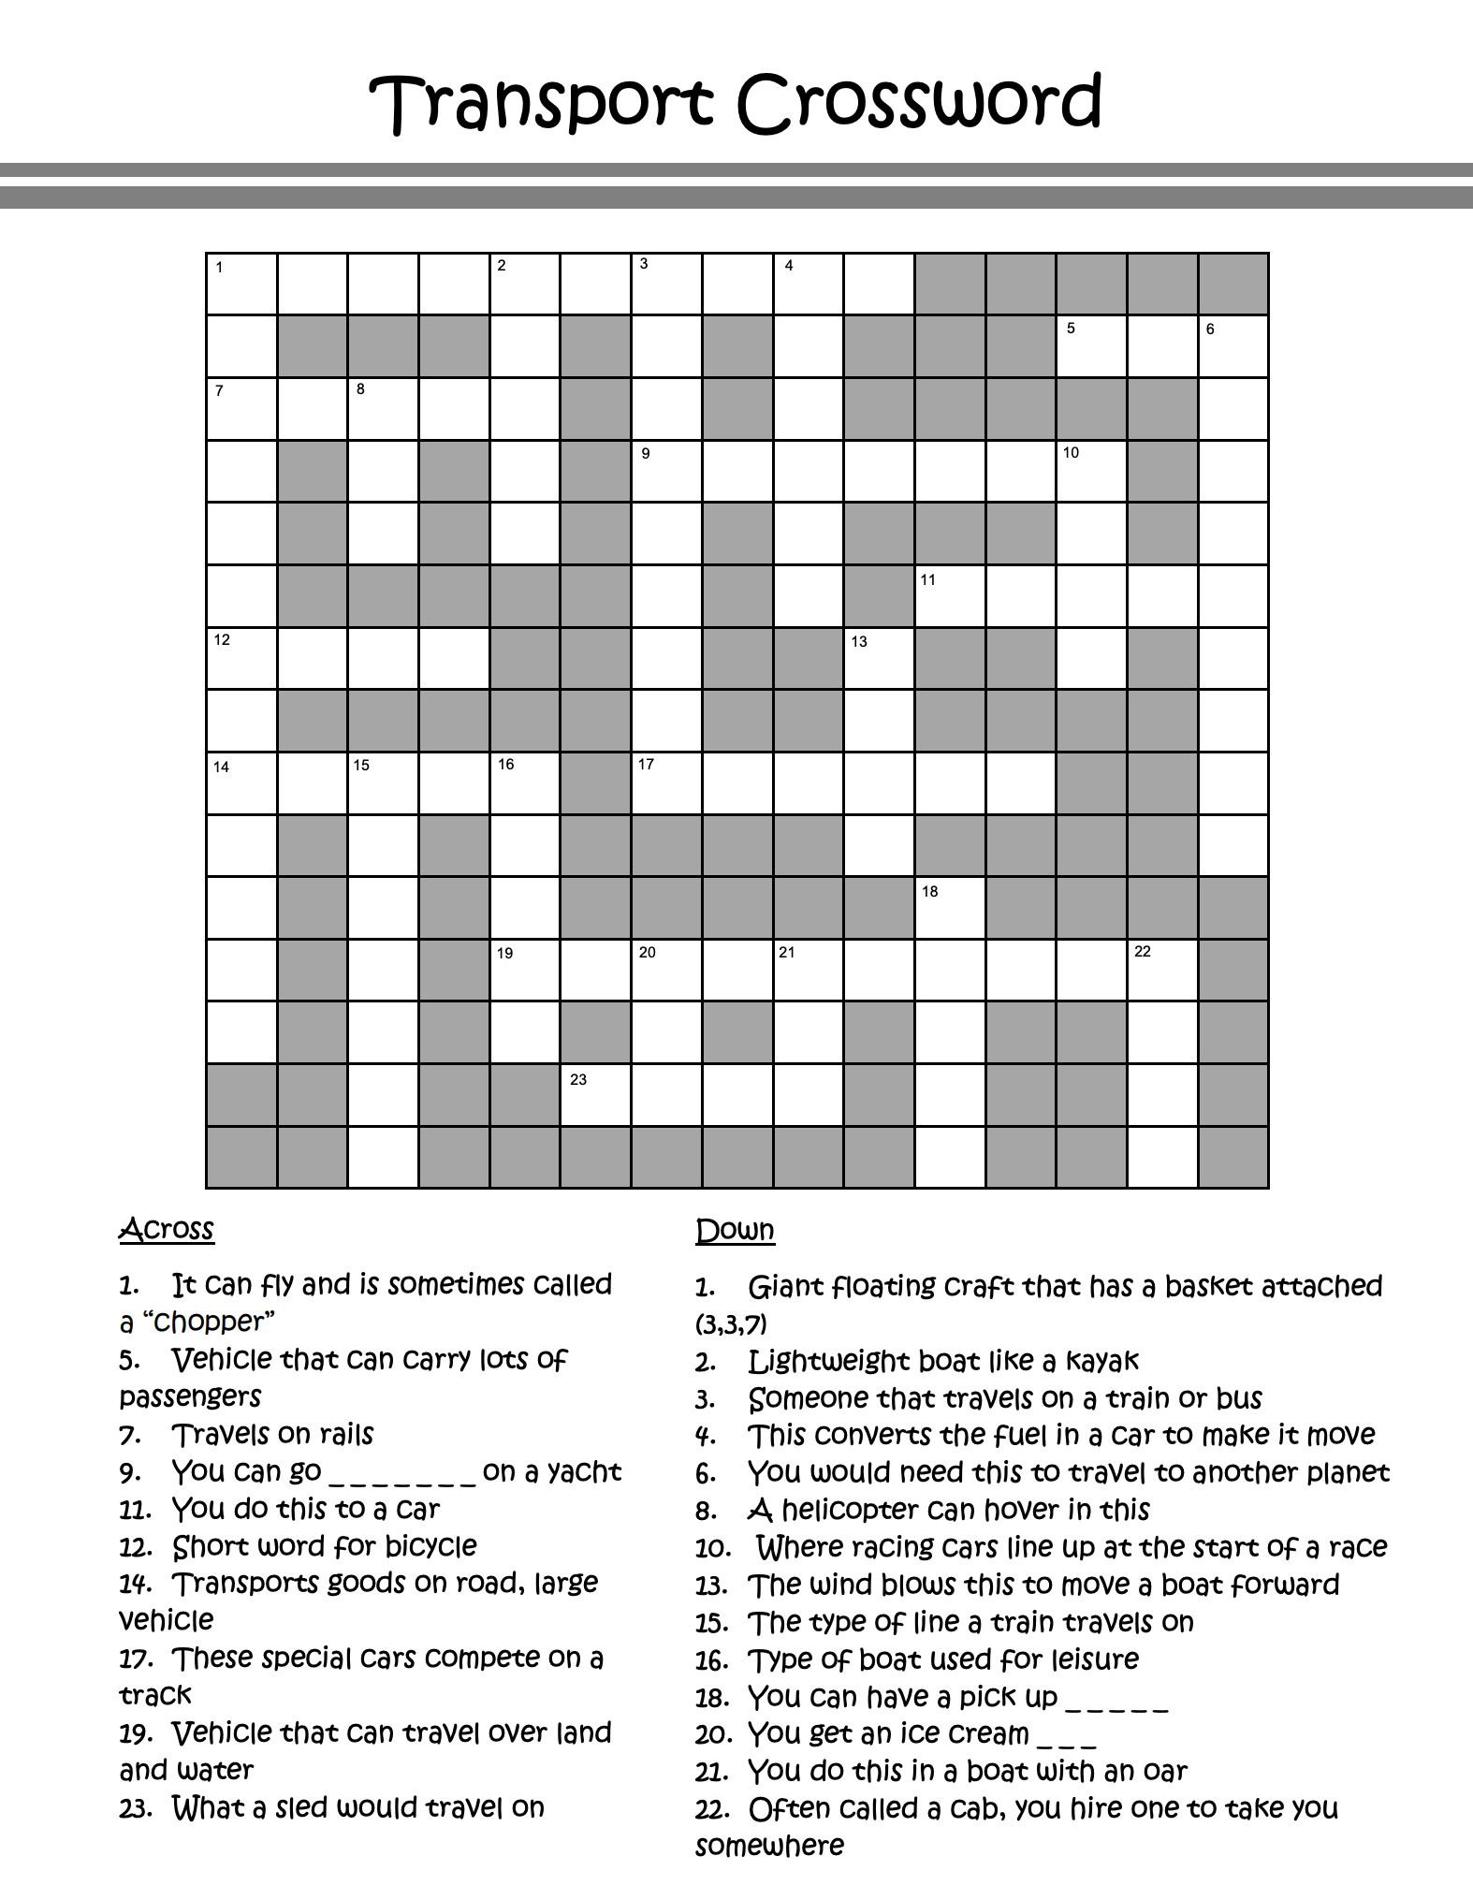
from www.kidspuzzlesandgames.co.uk

Crossword Template

Choose a theme. Write in words to fit. Make up clues for your words.

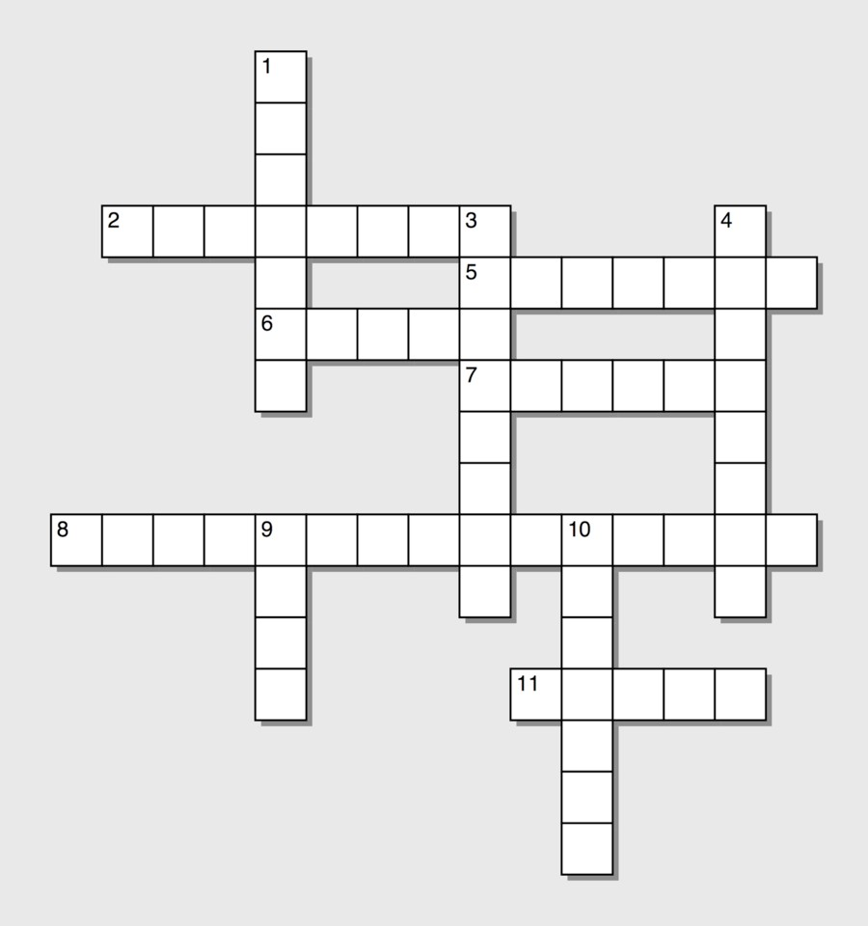

Crossword Answers
Minibeasts:
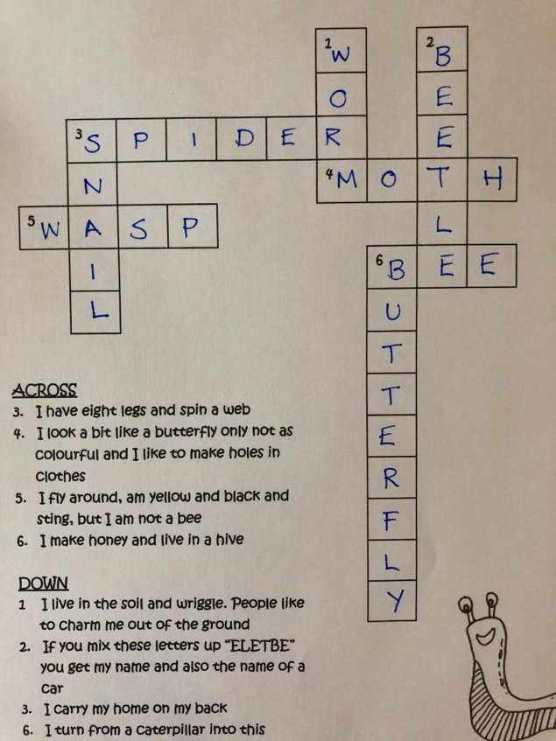

Pets:
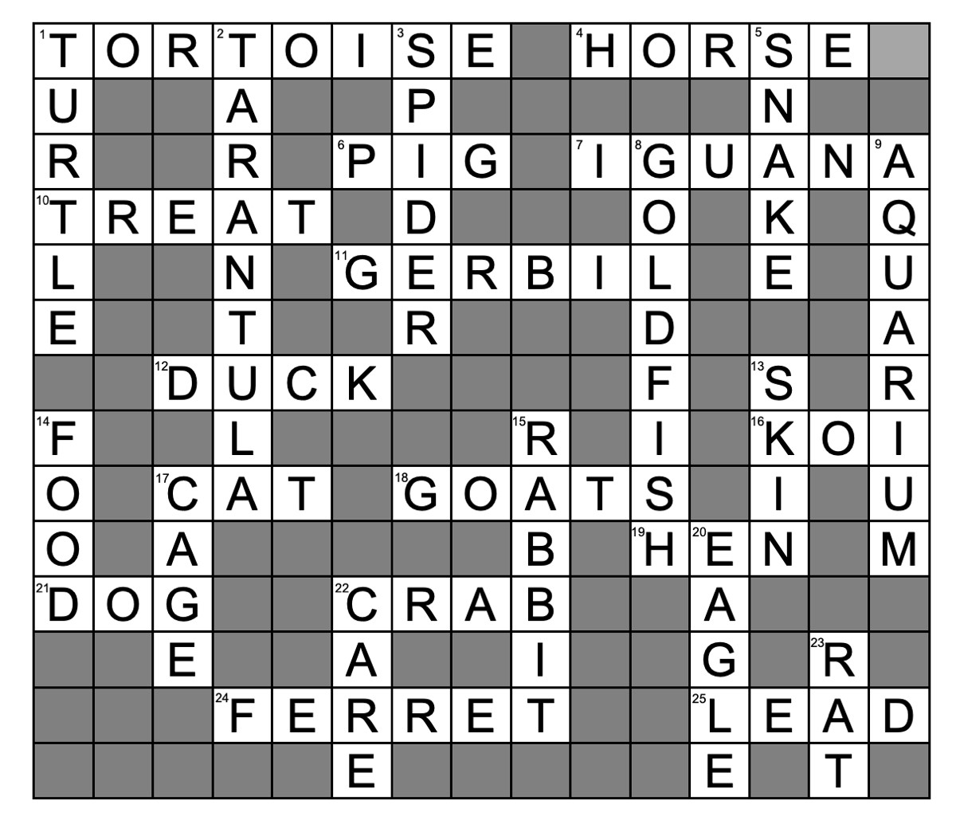

Transport:
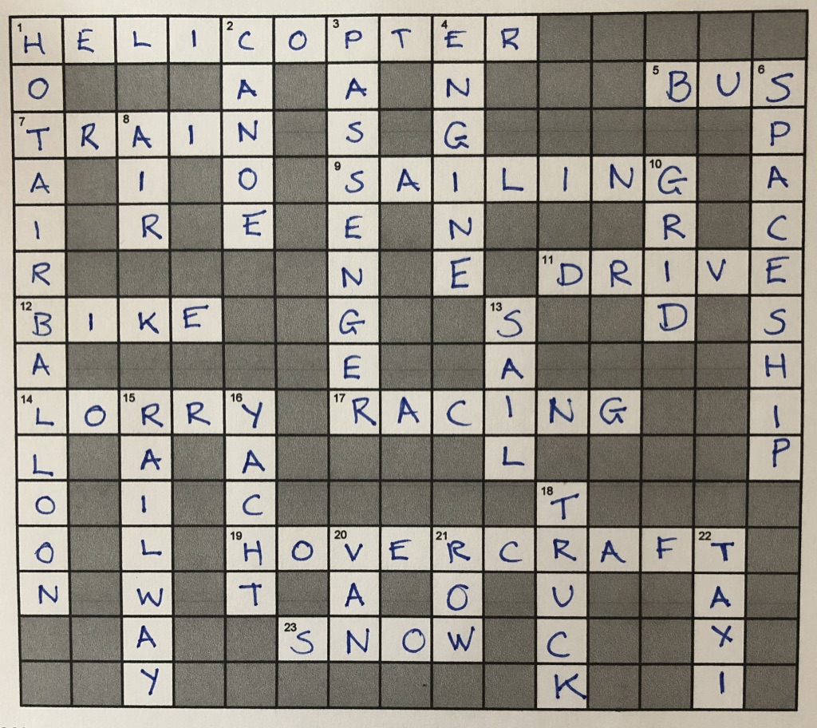

Example of Puzzle
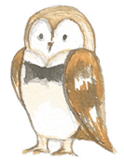
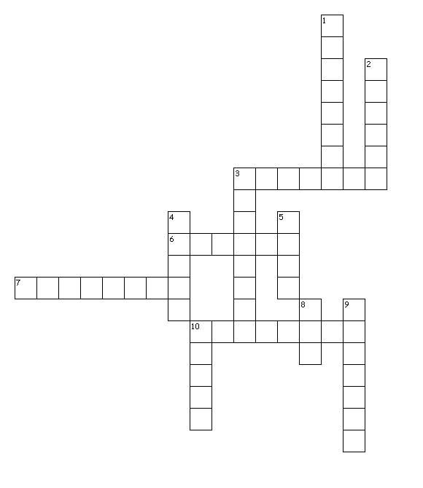
Across
3. Winged horse
6. Goddess of wisdom
7. Condemned to stay in the underworld
10. Half man half bull

Down
1. Clever inventor
2. Flew too close to the sun
3. God of the sea
4. God of the underworld
5. Anagram of S U Z E
8. God of nature
9. Lute player
10. Gold-loving king

