Dear Parents
I hope you all enjoyed half term.
Our new topic is Scented Garden and is all about plants and flowers. Hopefully this will be something the children will enjoy if the weather continues.
If you have any questions, please do email and I will get back to you as soon as I can.
With regards to Zoom calls, I would love to find a time to do this but with the changes happening in schools can you please just give me a bit of time to get my head around it and see when the best time would be for us to do the calls.
Sending big hugs to all the children
Mrs Burnett x

English
English continues to be through Hamilton. I have attached the work that is needed. Please remember there are lots of tasks on some of the days so please feel free to pick and choose the ones which motivate your child.

Maths
Maths continues to be through White Rose. The videos are still online and the link is below. I have attached the worksheets and answers for you.
https://whiterosemaths.com/homelearning/year-2/

Topic
Parts of a Plant
I have attached a PowerPoint about the parts of a plant. The children could have a flower and take it apart and have a look at each part of the flower. They could draw or paint their own flower and then label it. (Some of you may have already done something similar from the work Mrs Boden sent out)
Andy Goldsworthy
I have attached a PowerPoint about the artist Andy Goldsworthy who uses natural materials to create art. The children can have a go with anything they have at home or if it is safe to do so when you are out on walks etc. I would love to see some of the pieces the children create. I have added photos of some of the work the children have done in previous years.

Herb Garden
If you have the space to the children can create a herb garden and watch the herbs grow then taste them and feel the textures. Later this half term I will send some ideas to make scented playdough and biscuits.

Observing a seed grow
I have attached a sheet for the children to draw how their seed grows. It may be worth checking every few days to begin with. They should put the day in the bottom box and draw a picture to see how it changes. You could do this with one of the herbs or with something like sweetpeas which grow quickly.

Craft Ideas
I have attached some lovely craft ideas and links that the children may like to have a go at over the next few weeks.
https://www.redtedart.com/3d-paper-flowers/
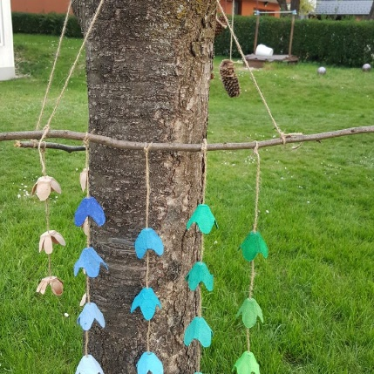
https://iheartcraftythings.com/3d-flower-crafts.html
