Hi everyone
I hope you are all okay and managing to keep everyone in your families safe and occupied.
Below is the home learning for next week. As our topic is all about the local area and also looking at how the area has changed I thought we would have a theme each week for the topic side of learning. The week’s topic will be linked to the seaside and how the seasides have changed, including the impact we as humans have had on this. I thought this would allow you to have some fun with the theme and think of other things to be able to do linked to this should you want to.
Thank you so much to all of you who have sent through things which the children have done. It really is lovely to see all the wonderful things they are up to and also the lovely messages and videos they have been sending. I will reply to all emails. It may take a couple of days as I am still in school teaching but please don’t stop sending them as I love receiving them from you.
There are lots of ideas below as well as the maths and English. Please don’t feel you have to do all of these. These are ideas for you and lots of them are independent as I appreciate many of you are also trying to work from home too.
I have also attached spellings for this half term. Apologies in the delay of these.
I am really missing all the children. Please do give them a big hug from me.
Mrs Burnett
MATHS
As last week the maths is via White Rose and continues to have a video to introduce each session.
https://whiterosemaths.com/homelearning/year-2/
ENGLISH
The English is through Hamilton and again is broken down into day by day. The instructions about what to do are at the beginning of each lesson. If you are struggling with any aspect of this, please do email me and I will help as much as I can.

TOPIC
Where I live
I have attached a little booklet the children could have a go at looking at where in the world they lie. It has some nice activities they could do. You could use an online map of the world and the UK if you don’t have an atlas at home. There are also some more independent activities in it.

Seaside Now and Then
There is a PowerPoint about the changes and similarities to the seaside. The children can have a look at this and then there is an activity where they can put the cut out pictures or draw pictures to show what has changed and what has stayed the same.
Reading
There is a differentiated reading task about beaches. The children can read through these and have a go at answering the questions. I have also attached some information pages about the seaside and the changes should you want to use these.
Plastic Pollution
I have attached a Powerpoint about plastic pollution and the impact humans have had on the sea and beaches. There is then a sheet with questions the children can have a go at answering.
Senses Poem
I have attached a sheet which the children could have a go at writing a poem about the different senses and what they see, hear, feel and smell at the beach.

Seaside Maths
I have attached a maths booklet that the children should be able to work on independently that has a seaside theme.

Other seaside ideas
I have attached images of lots of different activities you could do. Lots of these are independent and fun.
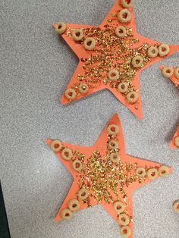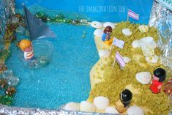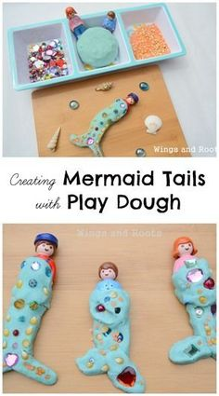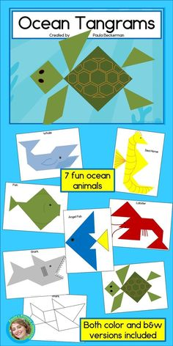
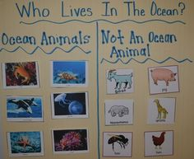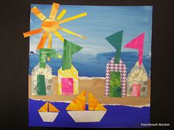
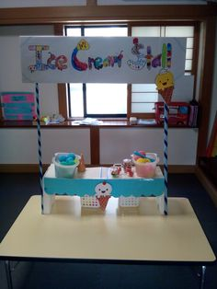
The children could make ice cream cones from paper and set up a stall. You could raid the penny pots and help them understand money and giving change. Thought they might find this fun.

