







PE Funding

Evaluation Form

Commissioned by

Created by

Images courtesy of Youth Sport Trust

PE Funding Evaluation Form

It is intended that this template should be used as preparation for the completion of the statutory digital reporting tool being introduced this academic year. You can upload data (including swimming) from this template onto this platform once it becomes accessible.
Before you decide how you are going to use the funding for this academic year you should reflect and evaluate the impact of your use of the funding in 2023/24.
All spending of the funding must conform with the terms outlined in the Conditions of Grant document. The template is a working document that you can amend/update during the year.
Based on your evaluation of last year’s funding you should decide what you intend to do this academic year, how you will do it, and what impact you expect it to have.

It is important that the funding is used effectively and based on your school’s needs.
You must use the funding to make additional and sustainable improvements to the PE and sport in your school. You must develop and add to the PESSPA activities that your school already offers.

Summative digital reporting from June 2025 will continue to include swimming and water safety information therefore funding can be used to provide top-up lessons where necessary to ensure pupils meet national curriculum swimming requirements.

We recommend that you start by reflecting on the impact of current provision and reviewing your previous spend

What went well? | How do you know?
PESSPA display board | In line with AfPE definition poster we have worked to ensure that staff and children understand the difference between Physical Education, School Sport and Physical Activity. Supporting this we have explained what this looks like in our school with examples. Display in prominent position in school with PE LTP, School Sport images and timetable for lunchtime activities.
Community club display board | Developed links with Graylingwell Girls and Lavant Youth to ensure chn can be directed to opportunities outside of school. Posters received from Chichester Rugby Club, Chichester Runners A.C., Climb Chichester and Junior Parkrun on display. Board on prominent position near hall for children and parents to see. Posters sent through from SGO’s are also on display.
Engagement with School Games calendar through WSW School Sport Partnership and Application for SGM Mark | Competitions and Festivals (Year Group) entered:  Autumn: Mixed Football Tournament (3/4) Girls Football (5/6) Sports Hall Athletics (5/6)  Spring: Cross Country (5/6) Netball (5/6) Tag Rugby (3/4)  Summer: Swimming Gala (4/5/6) Tri-Golf (3/4) QuadKids (3/4 and 5/6) Multi-Skills Festival (1/2) Cricket (5/6)  Data from School Sport participation %:  Year 1 – 33%  Year 2 – 33%  Year 3 – 48%  Year 4 – 86%  Year 5 – 70%  Year 6 – 73%  School Games Mark Application – Gold for 2023-2024
Introduction of Physical Education, School Sport and Physical Activity Council | PESSPA Council identified through Future Flyers programme. Children go round each class on occasions when there is a need in either Physical Education, School Sport or Physical Activity. Example questions:  Are you enjoying PE lessons?  What sporting clubs would you attend after school?  What activities or games would you like to play at break or lunchtime?  What equipment would like to play at break or lunchtime?  What activities do you currently do at lunchtime?
PE coach employed to increase knowledge, skills and confidence of all staff. | Staff report positively on sessions with PE Coach. On a half termly basis staff complete a Google Form reflecting on the unit of learning alongside the PE coach. Questions and responses below:  1. I am confident in assessing children's progress in PE for this unit.  2. I am confident in delivering a PE lesson for this unit.  3. I am confident with my subject knowledge in PE for this unit.  4. I am confident when progressing or scaffolding the learning for high attainers and SEND children for this unit.  Staff select: Strongly disagree/disagree/Neither agree of disagree/Agree/Strongly agree  Example response (Year 3):  - Agree  - Agree  - Agree  Agree
Physical Education Long Term Plan | Focus upon a Curriculum for Physical Education which enables motor competence, rules, strategies or tactics and healthy participation in line with OFSTED Research Review Series: PE (2022). We also identified the progression of skills, knowledge required at each step and sequence of learning. Working alongside staff from Southway Primary School the curriculum was updated in line with our intent for the subject.
Targeting physically inactive children at the school | Children are tracked to identify activities out of school which are undertaken. With CMO Active 30:30 initiative this is used to identify inactive children. % of children participating in extra-curricular clubs or activities out of school:  Year 1 – 67%  Year 2 – 70%  Year 3 – 70%  Year 4 – 63%  Year 5 – 77%  Year 6 – 67%  These children are then invited to participated in additional sessions with the PE coach and invited to join lunchtime activities run by Future Flyers and Bronze Ambassadors.
Sports Day format | Through speaking with staff and children we ascertain that the Sports Day needed some adjustments to ensure it was fun, active but remained competitive to all involved. Medals were on offer to children and a trophy was to be awarded to the winning house. Staff ran stations on a carousel of skills learnt in their PE lessons which was followed by running races on the track.  Please see feedback from Monitoring Visit by Governor Stephen Bennett on the 28th June 2024:  Observations and comments by the governor:  I attended the annual summer sports day. Whilst this was not a pre-planned monitoring visit, it was considered appropriate to provide comments and feedback to the LGB. A new format was run this year planned, it is understood, by Mr Lyttle (Y4 teacher). This was very effective and the combination of skills tests and athletics was both entertaining and challenging.  Pupil and parental voice:  I took the opportunity to interact with pupils and parents. The former clearly enjoyed the format  and sportsmanship and team spirit were greatly in evidence. The latter were universally positive and clearly enjoyed a great afternoon.
School Sport Newsletter Termly | Raising the profile of School Sport at the school through a termly Newsletter. Children are added with images of themselves participating along with event details. This is in line with the competitions and festivals organised by the WSW School Sport Partnership. We have also set-up a School Sport sponsorship model which is available to local businesses to finance kit and equipment. Currently we have one sponsor involved who purchased a brand new football kit for the A and B teams. Their logo appears on the School Sport newsletter.
Raising the profile of girls football at the school | We have developed a link with Graylingwell Girls who now run an extra-curricular club during the Summer Term. We were also successful in applying for a girls football kit through the Premier League and provided by Nike. We ran our own Extra-Curricular Girls Football Club for Years 5/6. Attended a local girls football tournament run by the school cluster group. Reached the finals of the Year 5/6 Girls Football Area for Chichester and Bognor.

What are your plans for 2024/25? | How are you going to action and achieve these plans?
Intent – Total Cost £17,766.47 | Implementation
Key Indicator 1: Increased confidence, knowledge, and skills of all staff in teaching PE and sport. - Cost £7,9250.00  Sports Coach to support staff CPD alongside staff to identify areas of need alongside Teaching Standards. Using the Long Term Plan staff identify area of PE they require support in.  Discuss with SGO opportunities for CPD being bespoke to the school rather than generic. Ensure any staff attending CPD are delivering this area of PE.  PE Leader to attend WSSP Conference. Regular emails from SGO and WSSP. | Staff to feedback via Google Forms following attendance at the session.  PE Leader to review model used in school to ensure Staff CPD is met.  Understand latest teaching and how to report PE and Sport Premium under new format.
Key indicator 2 -The engagement of all pupils in regular physical activity – the Chief Medical Officer guidelines recommend that all children and young people aged 5 to 18 engage in at least 60 minutes of physical activity per day, of which 30 minutes should be in school.- Cost £4,4491.47  Continue to replenish and use Pupil Voice to identify further equipment over break or lunch. This will provide greater provision for Physical Activity during these times of the day.  Complete audit of PE equipment to identify areas of need in order to ensure PE Long Term plan is delivered effectively.  Select a further 6 Year 5 children to undertake training. | Pupil Voice on an annual basis.  Focus upon equipment which is adapted to meet the needs of our children.  Once completed to buddy up with a Year 6 Sports Ambassador Ambassador in order to lead games or activities on a daily basis.
Key indicator 3 – The profile of PE and Sport is raised across the school as a tool for whole school improvement – Cost £40.00  Children to become Sports Council when moving into Year 6 to ensure a continued pathway for these children.  Continue to apply for Sports Mark next academic year and aim to maintain Gold Status with a view to achieving Platinum in academic year 2025/2026.  Model the use of iPads in the lesson to provide immediate feedback on technique (Gymnastics/Dance). | 6 Year 5 children to attend Future Flyers sessions. Each Future Flyer to be allocated a Year Group to compile Pupil Voice on PESSPA.  Application – Summer 2025.  Promote usage for evidence against PE using INSIGHT app along with use of Canva Floor Books.
Key indicator 4: Broader experience of a range of sports and activities offered to all pupils. - Cost £3,270.00  Continue to identify inactive children via PE and School Sport Tracker Document.  Contact Carl Tupper at Chance2Shine and organise Cricket CPD for staff who have the sport on their Long Term Plan. | Identify further opportunities on Extra-Curricular timetable for chn to attend.  Look to book coaches for Summer 1 in KS2.
Key indicator 5 - Increased participation in competitive sport - Cost £665.00  Explore opportunities through WSSP for coverage across the school. Ensure all children have the opportunity to represent the school at least once in Years 1-6. Continue to produce termly School Sport Newsletter.  Contact Schools in local area for friendly fixtures which we can host on school field, playground and school site. | Use tracking document to ensure children are recorded once they have attended a School Sport event.
Swimming Data - Meeting National Curriculum requirements for swimming and water safety Cost £1,3750.00  To ensure children are able to swim competently over a distance of 25 metres, use a range of strokes and perform self-safe rescue by the end of Year 6 | Track swimming attainment from Year 4 core lessons, Year 5 swimming top-up swimming lessons and completion of Ten-B Mini Medics course

What impact/intended impact/sustainability are you  expecting? | How will you know? What evidence do you have or  expect to have?
More Teaching staff developing their confidence and competency in Physical Education.  Staff benefit from CPD which they can immediately include in their teaching of Physical Education.  Ensure the subject is developing in line with the latest pedagogical approaches. | Google Form feedback
Physical Activity provision at break and lunchtime is replenished on a regular basis ensuring more children meet the CMO guidelines of 30 minutes in schools.  Children have greater access to equipment ensuring all children can access the learning across the Physical Education curriculum.  More children leading over break and lunchtime. Greater number of children across the school are involved and engaged in Physical Activity. | Greater number of children are physically active over playtimes.
Develop the PESSPA curriculum in line with the requirements of our children. Ensure model of identifying Future Flyers is identified for the next academic year.  Continue to show commitment to the School Games.  Children become adept at using iPads and prevalent in Physical Education lessons. All classes to have their own iPad to support learning in the subject. | School Games Mark to achieved at Gold Level and apply for Platinum.
Tracker in place each academic year using data from class teachers and Arbor to identify chn who could benefit from additional Physical Activity.  Develop relationships so Summer 1 is staff feeling more confident when delivering Striking and Fielding activities. | Record of children in each year group who have attend clubs/activities out of school.  Feedback from sessions in Chance2Shine coaching.
All children to receive opportunity to represent the school once each year. Identify regular competitions which school will attend.  Develop relationships with local PE leaders as part of GAS and Chichester area identifying regular fixtures between schools | School Sport Newsletter and tracking document to evidence participation levels.  Attend events locally separate to WSSP partnership.
All children from Years 4 to have had 20 swimming lessons and water safety course qualification across their time at the school. Core swimming lessons (Year 4), Top-up swimming lessons (Year 5) and Mini Medics Qualification (Year 6). | Swimming attainment percentages to improve from previous year (See below for 2023-2024 data) against the three criteria:  What percentage of your current Year 6 cohort can swim competently, confidently and proficiently over a distance of at least 25 metres?-60%  What percentage of your current Year 6 cohort can use a range of strokes effectively [for example, front crawl, backstroke, and breaststroke]?- 57%  What percentage of your current Year 6 cohort are able to perform safe self-rescue in different water-based situations?- 60%

What impact/sustainability have you seen? | What evidence do you have?
Staff are now more confident in delivering our PE Curriculum. The long-term plan is sustainable and consistent coaching will provide staff to lead the units the following academic year. This is then tracked to ensure staff are not receiving coaching in the same unit, subject to class teachers remaining in the same year group. | Google Form Feedback on a half termly basis a reflective tool for staff. See example template below:  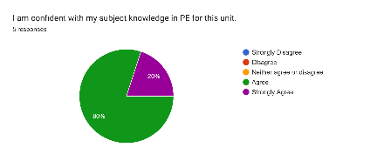  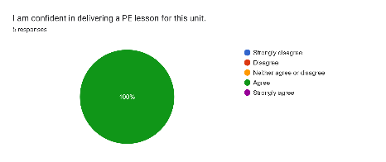  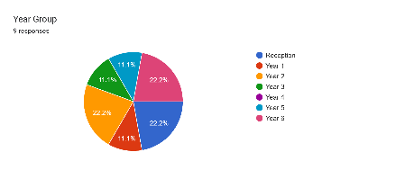
Children now have regular access to equipment at playtimes ensuring provision is in place guided by Pupil Voice coordinated by the PESSPA Council. Tracking document used to identify the inactive children at the school. | Children feedback was specific to the equipment (hoops, tennis balls, cones, etc). This is then supplement by a lunchtime leader pathway where Year 6 support the next age group to complete their Bronze Ambassador/Future Flyer programmes. Children are tracked to identify activities out of school which are undertaken. With CMO Active 30:30 initiative this is used to identify inactive children. % of children participating in extra-curricular clubs or activities out of school:  Year 1 – 66 %  Year 2 – 67%  Year 3 – 70%  Year 4 – 67%  Year 5 – 63%  Year 6 – 74%  These children are then invited to participated in additional sessions with the PE coach and invited to join lunchtime activities run by Future Flyers and Bronze Ambassadors.
PESSPA Council in place each academic year alongside Future Flyers and Bronze Ambassadors.  School Games Mark completed throughout the year. | Leadership roles in place and active throughout the year.  Gold – School Games Mark achieved in July 2025 and application to Platinum successful and verified by SGO.  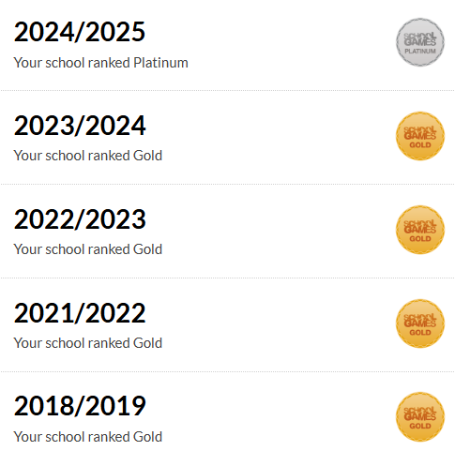
Range of competitions and festivals entered on a consistent basis to aspire for majority of children to represent The March in School Sport. Model of tracking attendance in place to ensure each year percentages to increase. | Competitions and Festivals (Year Group) entered:  Autumn: Mixed Football Tournament (3/4) Girls Football (5/6) Sports Hall Athletics (5/6)  Spring: Cross Country (5/6) Netball (5/6) BenchBall (5/6)  Summer: Swimming Gala (4/5/6) Tri-Golf (3/4) QuadKids (3/4 and 5/6) Multi-Skills Festival (1) GAS Sports Day (2/3/4/5)  Data from School Sport participation %:  Year 1 – 100%  Year 2 – 6%  Year 3 – 44%  Year 4 – 81%  Year 5 – 60%  Year 6 – 78%
Contact in place with local schools to ensure communication and awareness of local events.  SGO in contact and full calendar in place to ensure balance between competitions and festivals throughout the academic year. | Arranged fixtures –  Year 6 Football Tournament – Local Chichester Area  Year 5/6 Girls Football Fixture – Portfield Primary Academy  Year 3/4 Girls Football Fixture – Portfield Primary Academy
Model of core funded swimming lessons for children in Year 4, top-up swimming lessons for Year 5 via attainment results and safe-self rescue in place (Ten-B Mini Medics qualification)  * Ten-B have contributed to water safety, first aid and learnt about safe self-rescues and given the knowledge on how to perform these. However, without being in the water and assessing them we can’t provide a percentage figure of who is to “perform” in these situations. | What percentage of your current Year 6 cohort can swim competently, confidently and proficiently over a distance of at least 25 metres? - 60%  What percentage of your current Year 6 cohort can use a range of strokes effectively [for example, front crawl, backstroke, and breaststroke]? - 48%  What percentage of your current Year 6 cohort are able to perform safe self-rescue in different water-based situations? - 39%*

