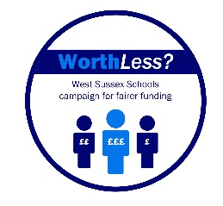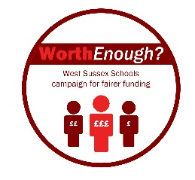January 2017

Dear Parent / Carer

**Worth Less? Worth Enough?**

As promised, please find below an update on the school funding situation for schools in West Sussex.

Following publication of the second part of the National Funding Formula (NFF) consultation, school leaders across West Sussex are saddened by the fact that for many schools the financial situation does not look like it is improving either in the short or longer terms. Key headlines are as follows:

* As yet, no interim funding has been offered to West Sussex schools for the year 2017/18.
* The NFF will begin in April 2018, the new proposals allocate funding with greater fairness and transparency as all schools across England are funded via the same methodology.
* These new arrangements are, however, being severely undermined by:
  + The ongoing introduction of unfunded costs being placed upon schools, such as increasing employer NI and pension contributions as well as Educational Service Grant costs. These “stealth taxes” lie outside of the NFF.
  + Schools not receiving adequate “core funding” to meet basic staffing and equipment costs.
  + The government’s decision to make £3 billion of “efficiency saving” from school budgets.

Using data from WSCC and the DFE’s own database, under current NFF proposals the following will occur:

* In 2018 West Sussex schools will, on average, gain a further £79 per pupil rising to £144 in April 2020.
* After the introduction of NFF (2018), unfunded cost burdens will, however, mean that such gains are offset to the point where the vast majority of schools in West Sussex will be no better off (or even worse off) than the current dire financial situation.
* In terms of funding received, West Sussex schools will remain 148th out of 151 Local Authorities.

The new NFF arrangements are relatively complicated and more in depth analysis can be found via this document:



Headteachers in all West Sussex schools are dismayed that our financial situation looks so bleak. As a consequence, our fears about reduced staffing levels, increased class sizes and reductions in curricular and pastoral provision are likely to become a reality in either the short term, medium term or both.

School Leaders are united in their belief that the current situation is both unfair and unsustainable. Previously we were made to feel that pupils in West Sussex were “Worth Less”, under the new arrangements they simply don’t appear to be “Worth Enough”.

Our first step is to raise important questions with ministers from the DFE and our own local MPs. We are happy to share these questions with you and would urge you to raise similar concerns with your local representatives.



We will continue to do everything in our power to maintain standards of care and provision but also feel that it is important to let you know just how bad matters are at present. Your support as we continue with our campaign will be vital.

Yours sincerely

*Insert Headteacher Name*

And on behalf of Primary, Secondary and Special School Headteacher Executives