Year 3 Home Learning
Week of 11th May 2020

Spellings
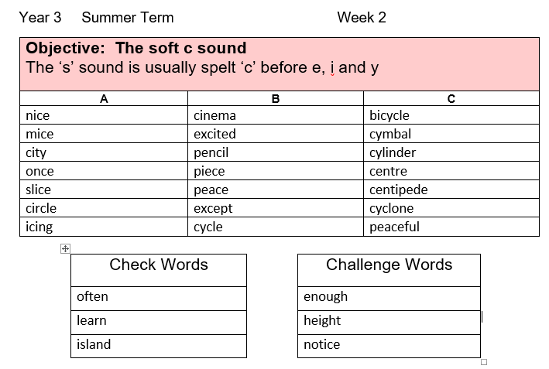

Maths
White Rose Home Learning: https://whiterosemaths.com/homelearning/year-3/.
Each day there is a short video followed by a written activity. If you are not able to print the sheets do not worry at all, you can record the answers on a piece of paper. Once you are finished you can check your answers on the resource provided.
We are now on Summer Term Week 2 – w/c 27 April: https://whiterosemaths.com/homelearning/year-3/
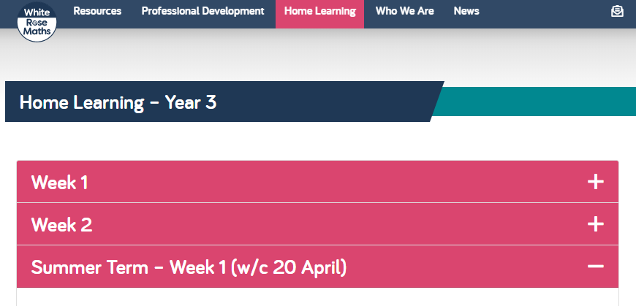

Activity 1
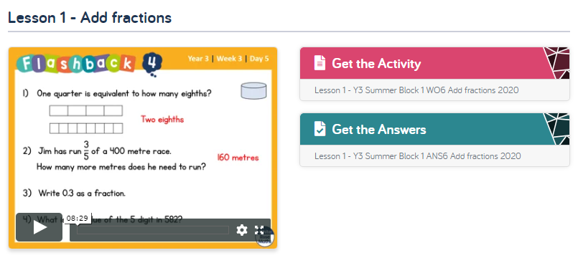
Activity 2
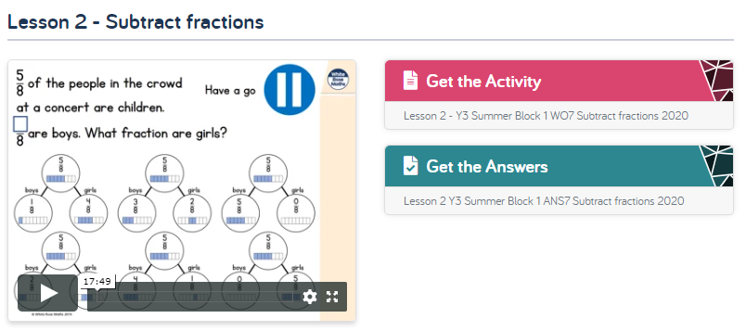
Activity 3
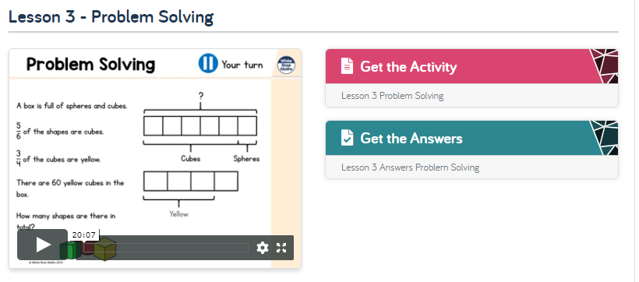

Activity 4
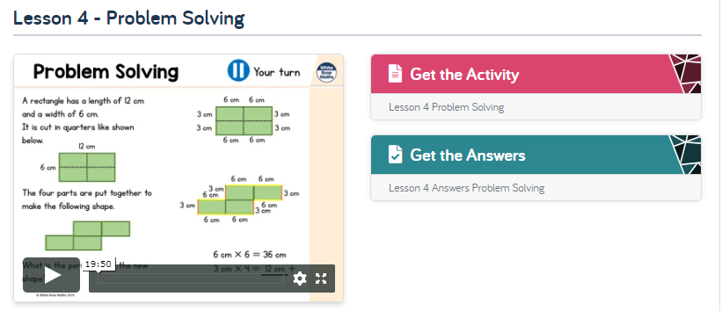
Activity 5
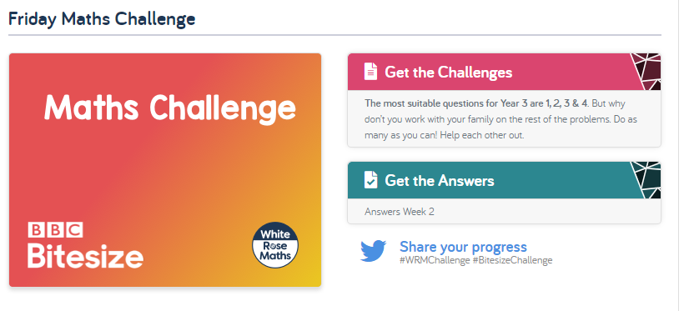

English
Hamilton Trust – Year 3 English – Week 4
https://www.hamilton-trust.org.uk/blog/learning-home-packs/
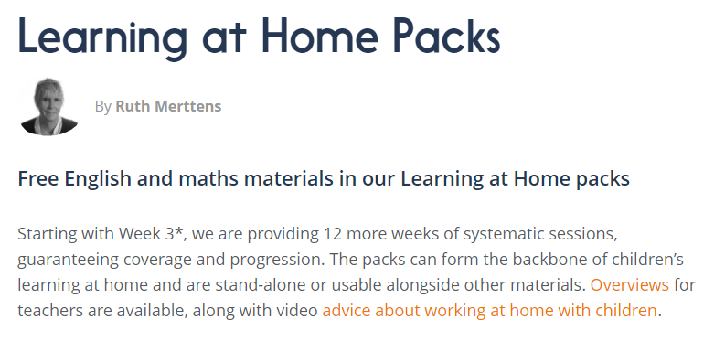
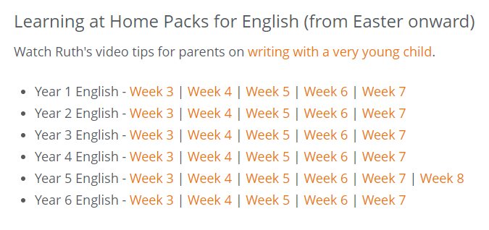

Topic Ideas
You can use our topic homework grid to complete topic or you could create some work or even a topic all of your own choosing. Just have fun and keep safe.
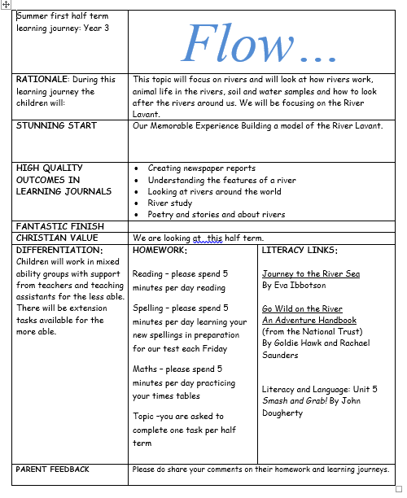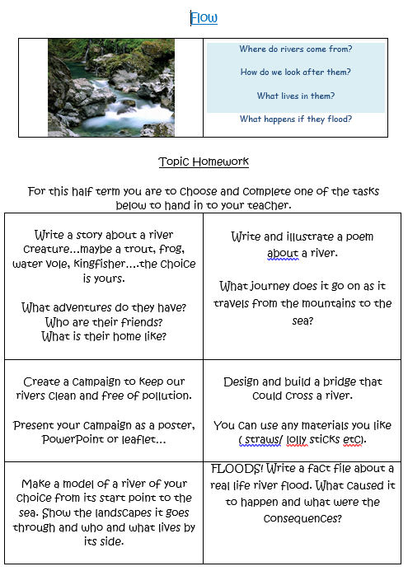

Here is a fun science experiment you can try…
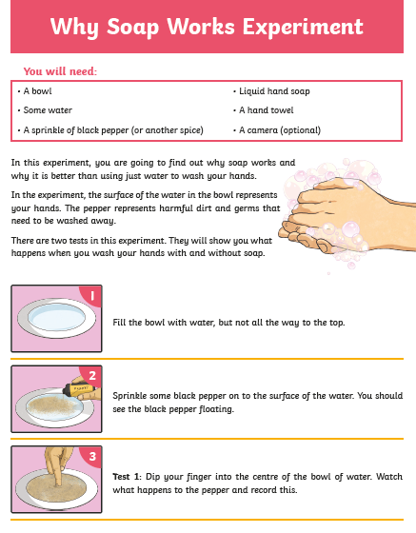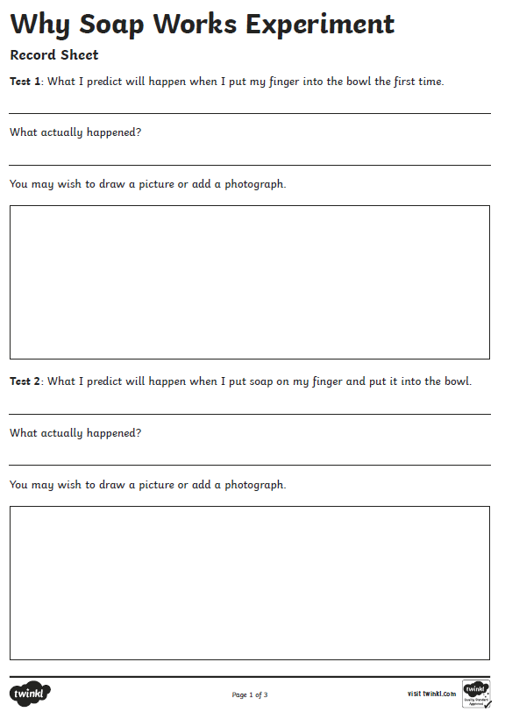

I have also attached an Art/DT activity if you would like to have a go.

