Hi all
I hope you all had a lovely Easter weekend and am sure it was very different to normal.
It was really great to see so many of the children on the Zoom chat on Tuesday. I really hope we can make this more of a regular thing.
Here are the links etc for next week’s work. There are a few topic ideas too and you may find that the children want to spend time working on one of them in detail rather than a bit of time on each. Please do use the topic parts how it works best for you.
Please do keep sending through the work the children have been doing as it is really lovely to see what they have been doing. Also if I can be of any help with any of the work, please do ask.
Mrs Burnett

Maths
The Maths for the next week is from White Rose which I hope you will find useful. This is the link to the maths.
https://whiterosemaths.com/homelearning/year-2/
Each day has a video to explain the work to the children and then activities and the answers. I appreciate some of you don’t have access to a printer but the children can still view the work and then use paper to do the answer. If you find your child struggles with this, you can use the Year 1 section instead as in school we would differentiate the work. It may be some areas of maths they access the Year 1 and others they access Year 2. This is perfectly okay.
Year 1 link
https://whiterosemaths.com/homelearning/year-1/

English
The English is attached and has a story and activities for each day. Please pick and choose the activities that suit your child as some days has a lots of activities to work through. The are instructions for each day.
It would be lovely for you to send through one piece of English work each week to my email and I will give feedback to the children. Please don’t think that it has to be a best, beautifully presented piece of work it should just be something you’ve worked on over the week.

Topic
Our topic for this half term is Changes Places all about our local area and how it’s changed over the last 100 years. Here are some ideas for you to work on over the next few weeks.

History
Find out about Chichester has changed over the last 100 years.
Ideas –
Speak to family members to find out what has changed in the area since they have lived here e.g. Rolls Royce, Sainsbury’s, Chichester Gate, Chichester Festival Theatre, Aldi, housing developments. Lots has been built around the area. You could write down all the new things that have been built. Some family members may even have photos they can send you. There are also lots of photos online.

Chichester Cathedral and St Richard
Part of our topic was looking at the history of Chichester Cathedral and St Richard.
This stained glass window by Marc Chagall has a beautiful meaning behind it. The children can research this as there is lots of information about it.
Here is a link to the Chichester Cathedral website about the window.
https://www.chichestercathedral.org.uk/visiting/cathedral-plan/delve-deeper-marc-chagall-window

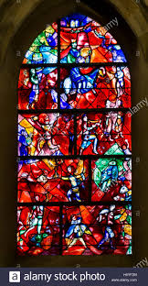
The children can then design their own stained glass window. Depending what you have at home they could paint, colour, collage theirs. I am hoping we will be able to do anther Zoom call at 11am on Friday 24th April and it would be lovely if the children brought what they had designed to show everyone. ( No pressure though). Here are a few ideas below.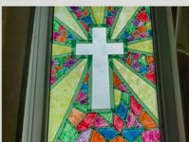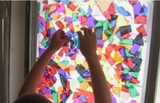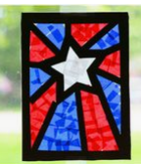

Quite a few of the children have sent me pieces of art they have been working on using draw with Rob. I have attached the link for you below in case you haven’t seen this.
http://www.robbiddulph.com/draw-with-rob

Art
Sketch a picture of Chichester Cathedral. It would be good for the children to work on the sketching techniques too. This is the best example of sketching techniques I could find but may be good to pause at certain parts and get the children to have a go. They could do this on scrap paper and it may be that they spend time learning the different sketching techniques and don’t get as far as the Cathedral sketch this week.

