What to do today
IMPORTANT Parent or Carer – Read this page with your child and check that you are happy with what they have to do and any weblinks or use of internet.

1. Read a Poem
- Read Sheep in Winter. Read it twice – once in your head and once out loud. What do you notice about the rhyme scheme?
- Think about the poem from Day 4 (The Cow). How is this poem similar? How is it different? Which poem do you prefer? Why?

2. Remind yourself about adverbs
- Use the Revision Card to remind yourself about adverbs.
- Complete Animal Adjectives and Adverbs.

Well done! Now show a grown-up your answers to the questions. Show the adverbs that you have chosen.

3. Read more animal poems
- Read four more animal poems: Rabbit Poem, God laughed when he made the duck, Duck’s ditty and The Sparrow.
- Find adverbs used in these poems. Underline them if you can. You can check your answers at the end of the pack.
- Choose your favourite poem and practise reading it aloud. The Top tips for reading a poem aloud will help you to do this.

Try these Fun-Time Extras
- Can you choose your favourite poem and copy it out carefully in your best handwriting? You could add an illustration when you have finished.
- Can you try to write a poem called Sheep in Summer? How could it be the same as the original? How could it be different?

Sheep in Winter

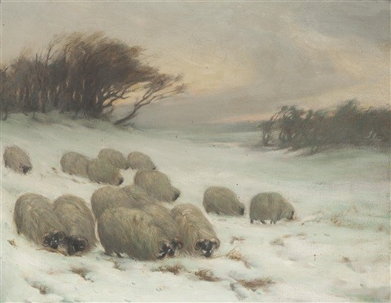

The sheep get up and make their many tracks
And bear a load of snow upon their backs,
And gnaw the frozen turnip to the ground
With sharp quick bite, and then go noising round
The boy that pecks the turnips all the day
And knocks his hands to keep the cold away
And laps his legs in straw to keep them warm
And hides behind the hedges from the storm.
The sheep, as tame as dogs, go where he goes
And try to shake their fleeces from the snows.
Then leave their frozen meal and wander round
The stubble stack that stands beside the ground,
And lie all night and face the drizzling storm
And shun the hovel where they might be warm.
By John Clare

Revision Card – Adverbs

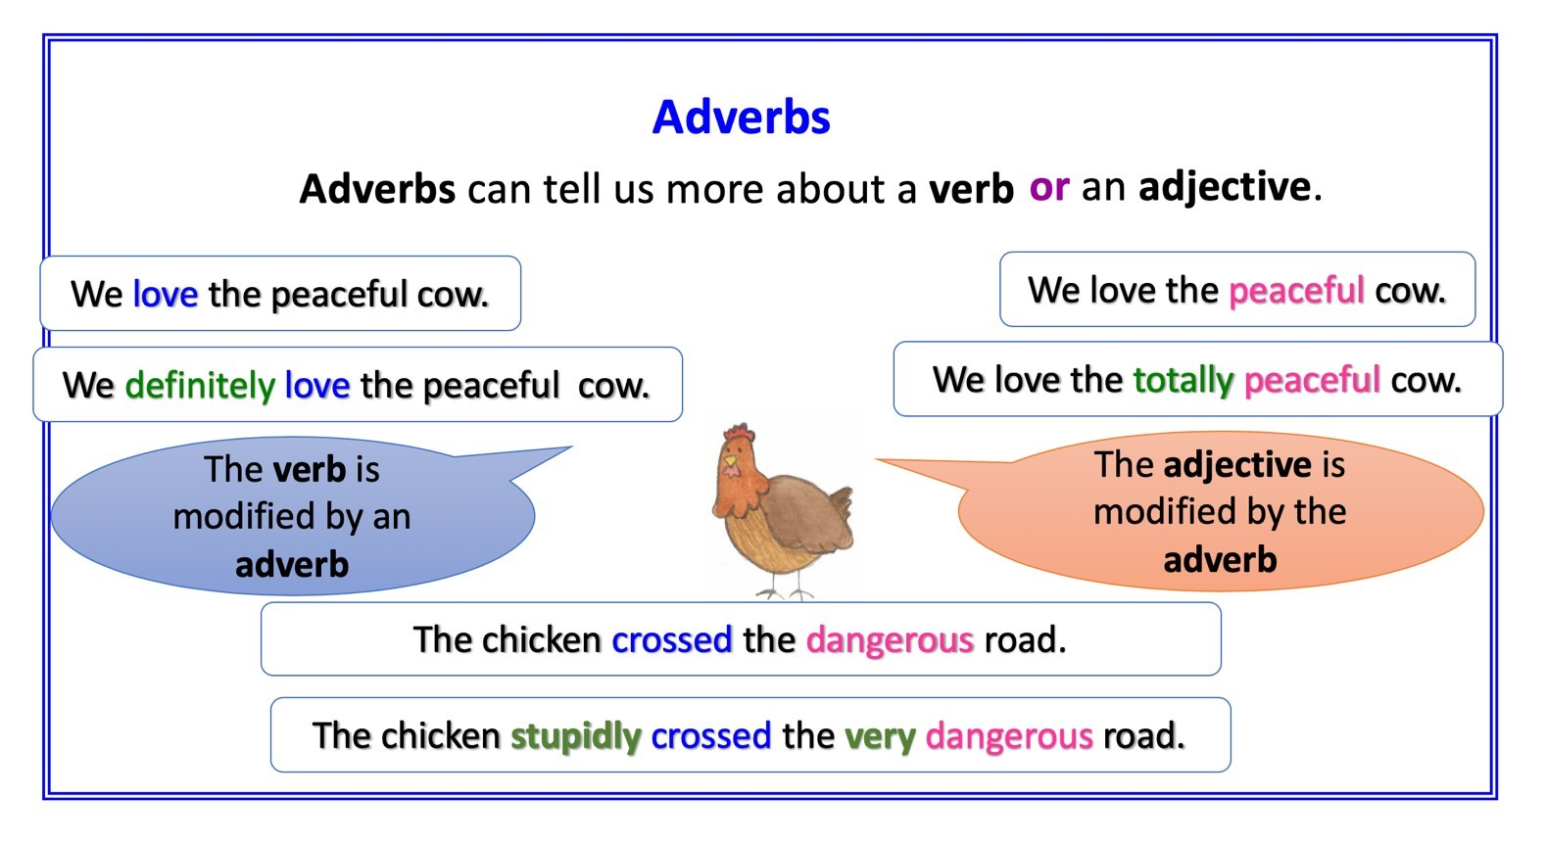
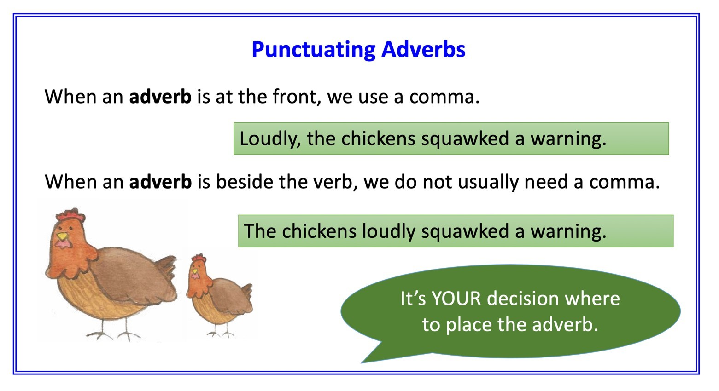

Animal Adjectives and Adverbs

There are some adverbs on cards below to help you.
Underline the adjectives in each sentence. Draw a circle round the adverbs.

- The cows are so cold. They need much warmer coats.
- The very clever pigs manage to open the almost closed gate.
- Sheep sleep for quite long periods in the really hot summer.

Modify each adjective using at least one adverb.
Write your own description of the rabbit using at least two adjectives and adverbs.

Cow | The ___________ happy cow was _________ gentle.
Sheep | The ________ frozen ground gave little shelter to the  _________ cold sheep.
Pig | __________ contented pigs have plenty of food.  They also like to play in a _________ sizeable pen.
Rabbit

very |  | really |  | totally |  | mostly |  | quite
fairly |  | much |  | normally |  | completely |  |  | so

Rabbit Poem

To keep  a rabbit  is a good  habit.  A rabbit is truly curious:  his eyes are soft  but his whiskers wiggle  and his nose twitches  and his ears jiggle  and his tail  is a bump  on  his rump.  A rabbit  is cheerful  but not especially  careful  about multiplying  the answers  he gets  to the simple  sum  of one and one  are mystifying. . . | A rabbit is easy  to care for:  to munch on grass  is what he is hare for.  So if you get  the chance  to have a rabbit,  grab it!  By Pamela Mordecai  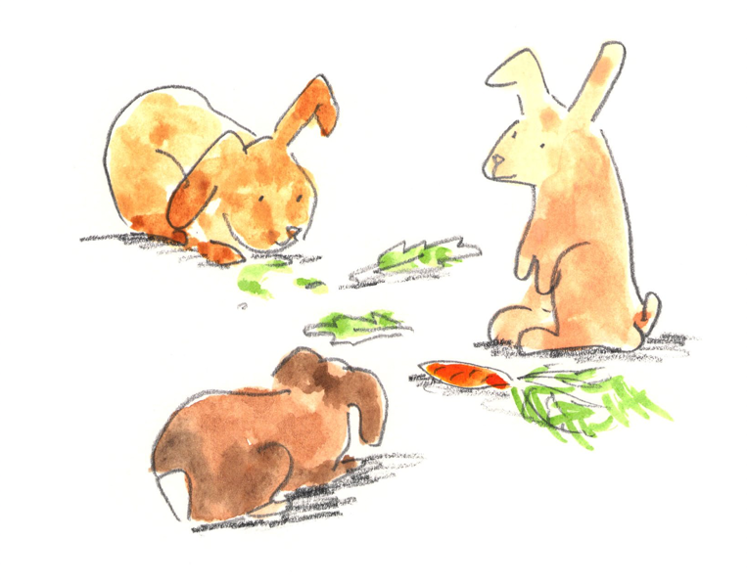

God laughed when he made the duck

When God had finished the stars and whirl of coloured suns
He turned His mind from big things to fashion little ones;
Beautiful tiny things (like daisies) He made, and then
He made the comical ones in case the minds of men
Should stiffen and become
Dull, humourless and glum,
And so forgetful of their Maker be
As to take even themselves – quite seriously.
Caterpillars and cats are lively and excellent puns:
All God’s jokes are good – even the practical ones!
And as for the duck, I think God must have smiled a bit
Seeing those bright eyes blink on the day He fashioned it.
And he’s probably laughing still
at the sound that came
out of its bill!
By F W Harvey | 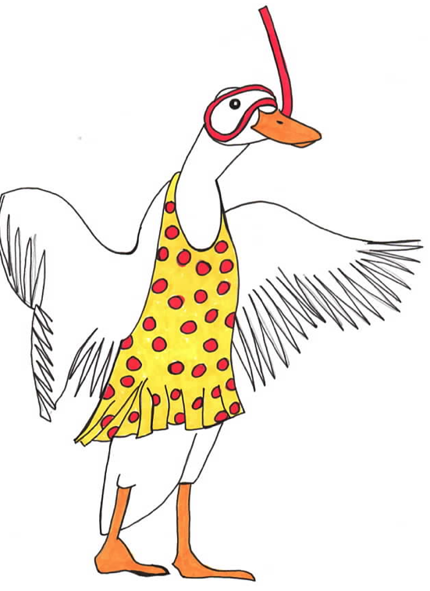

Ducks’ Ditty

All along the backwater,
Through the rushes tall,
Ducks are a-dabbling,
Up tails all!

Ducks’ tails, drakes’ tails,
Yellow feet a-quiver,
Yellow bills out of sight
Busy in the river!

Slushy, green undergrowth
Where the roach swim –
Here we keep our larder,
Cool and full and dim.

Every one for what he likes!
We like to be
Heads down, tails up,
Dabbling free!
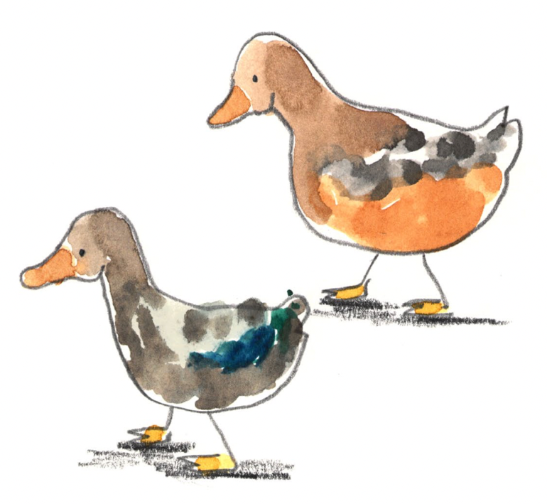
High in the blue above
Swifts whirl and call,
We are down a-dabbling,
Up tails all!

By Kenneth Grahame

The Sparrow

I found a speckled sparrow
between the showers of rain.

He thought the window wasn’t there
and flew against the pane.

I picked him up and held him.
He didn’t stir at all.

I hardly felt him in my hand,
he was so soft and small.

I held him like a flower
upon my open palm.

I saw an eyelid quiver,
though he lay still and calm.

And then, before I knew it
I stood alone, aghast:

I never thought a bird so limp
could fly away so fast.

By Aileen Fisher

Top tips for reading a poem aloud

- Work on the tricky words. Find out what they mean and how they are said. Practise saying them.
- Look for the full stops. Make sentences flow to the full stop, even when there’s a new line.
- Slow down. Speak slowly when you’re reading a poem, so that others can hear the words.
- Project your voice. Imagine someone on the other side of the room and speak to them.
- Practise. Read and read and read your poem, so that you get better each time.

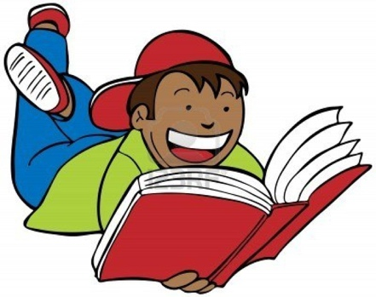

Adverb Search – Answers

In The Rabbit poem
truly modifies the adjective curious
A rabbit is truly curious:
his eyes are soft
but his whiskers wiggle
and his nose twitches
and his ears jiggle.

A rabbit
is cheerful
especially modifies the adjective careful
but not especially
careful . . .

In God laughed when he made the duck

. . . they take themselves quite seriously
seriously modifies the verb take

. . .
quite qualifies the adverb seriously

And he’s probably laughing still
at the sound that came
out of its bill!
probably and still both modify the verb is laughing

In The Sparrow
hardly modifies the verb felt
I hardly felt him in my hand,
he was so soft and small.

. . .
never modifies the verb thought

I never thought a bird so limp
could fly away so fast.
fast modifies the verb fly away

so qualifies the adverb fast

