What to do today
IMPORTANT Parent or Carer – Read this page with your child and check that you are happy with what they have to do and any weblinks or use of internet.

1. Watch part of a film
- Watch the first two and a half minutes (2:30) of The Homing Instinct here: https://www.youtube.com/watch?v=MdJ5q9cyPmk
- What can you see here that is in the story King of the Sky? What is different? What did you learn that was new?

2. Read and sort information
- Read the sentences on Pigeons 1. Cut these sentences out and decide which of the Headings they belong to.
- You could challenge yourself to read and sort the sentences on Pigeons 2 as well.

Well done! Show your sorted sentences to a grown-up. Tell them the three most interesting facts that you have read. You can check your answers at the end of the pack.

3. Research a famous pigeon!
- Use the Research Questions to find out about Mary of Exeter.
- Can you make a poster about Mary and her adventures, showing what you have learnt?

Try the Fun-Time Extra
- Can you find out about some other birds? You could pick one type of bird and find out about it. If you can see birds in your everyday life, you could find out about them.

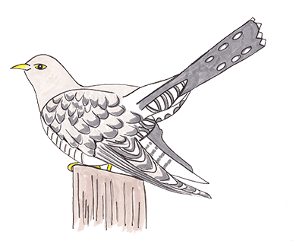
Pigeon Information 1

Pigeons have been given medals for their
bravery in wars.
The weather on the race day can be dangerous to pigeons.
Racing pigeons have bands attached to their legs so you can tell how long they have taken.
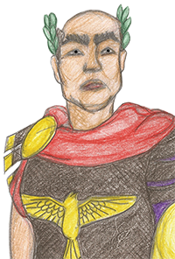
In 1918 a pigeon called Cher Ami delivered a message that saved 194 US Soldiers.
Birds are taken from their home lofts and then
have to race home.
Racing pigeons are trained by being taken
further and further away from their home.
Julius Caesar used pigeons to send messages.
Pigeons have been used in war since
ancient times.
Pigeon races can be from 100 km to 1000 km long.
A bird belonging to the queen of England won a race in 1990.

Pigeon Information 2

In Italy, in World War II, a pigeon called GI Joe delivered an emergency message that stopped the Allied air force from accidentally bombing their own men.
It is thought that homing pigeons use a magnetic force to help them find their way home.
In World War II, the United Kingdom used
about 250,000 pigeons.
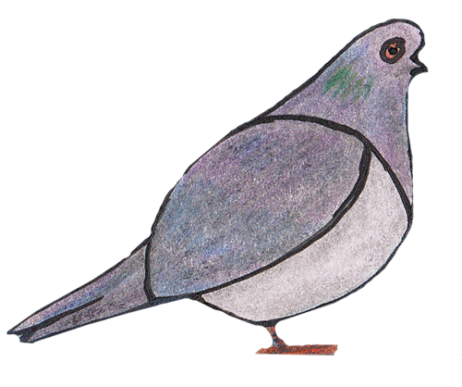
Some people think that homing pigeons use
landmarks to find their way home.
Racing pigeons can be at risk from birds of prey.
It is possible that pigeons use the position of the sun to guide them home.
Nearby enemy soldiers tried to shoot down pigeons,
knowing that the birds were carrying messages.
No-one is completely sure how pigeons are able to find their way home.
Pigeons have flown as far as 1,800 km to return to their home.
Most racing pigeons take part in races for three years of their life.
The sport of racing pigeons may go back to 220 AD.
Homing pigeons can get to their homes from long distances away.

Headings

Pigeon Racing
Homing Instinct
Pigeons in wars

Mary of Exeter – Research Questions

Use the Internet to find out answers to these questions. You could start with this website:

https://en.wikipedia.org/wiki/Mary_of_Exeter

- Why is Mary of Exeter famous?
- When was she alive?
- What was her greatest adventure?
- Where can people remember her today?

What else can you find out about this famous pigeon?
Pigeon Information – Answers

Racing Pigeons
Pigeon races can be from 100 km to 1000 km long.
The sport of racing pigeons may go back to 220AD.
Birds are taken from their home lofts and then have to race home.
Most racing pigeons take part in races for three years of their life.
The weather on the day of the race can be dangerous to pigeons.
Racing pigeons can be at risk from birds of prey.
Racing pigeons have bands attached to their legs to time how long they have taken.
Racing pigeons are trained by being taken further and further away from their home.
A bird belonging to Queen Elizabeth II won a race in 1990.

Pigeons in wars
Pigeons have been used in war since ancient times.
Julius Caesar used pigeons to send messages.
In 1918 a pigeon called Cher Ami delivered a message that saved 194 US Soldiers.
In World War II, the United Kingdom used about 250,000 pigeons.
In Italy, in World War II, a pigeon called GI Joe delivered an emergency message that stopped the Allied air force from accidentally bombing their own men.
Pigeons have been awarded medals for their bravery in wars.
Nearby enemy soldiers tried to shoot down pigeons, knowing that the birds were carrying messages.

Homing Instinct
Homing pigeons are able to return to their homes from long distances away.
Pigeons have made flights as long as 1,800km to return to their home.
No-one is completely sure how pigeons are able to find their way home.
It is possible that pigeons use the position of the sun to guide them home.
It is thought that homing pigeons detect a magnetic force to help them find their way home.
Some people think that homing pigeons use landmarks to find their way home.

