Year 3 Home Learning
Week of 22nd June 2020

Spellings
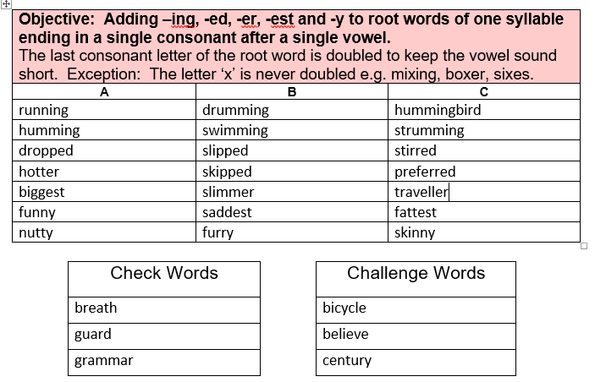

Maths
White Rose: https://whiterosemaths.com/homelearning/year-3/

White Rose Home Learning Summer Term – Week 9 (w/c 22nd June)

Worksheets emailed out as attachments

Activity 1

Lesson 1 - Right angles in shapes
Activity 2

Lesson 2 - Compare angles
Activity 3

Lesson 3 - Horizontal and vertical
Activity 4

Lesson 4 - Parallel and perpendicular
Activity 5
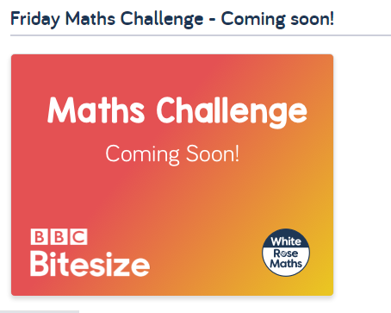

English
Hamilton Trust – Year 3 English – Week 9
https://www.hamilton-trust.org.uk/blog/learning-home-packs/
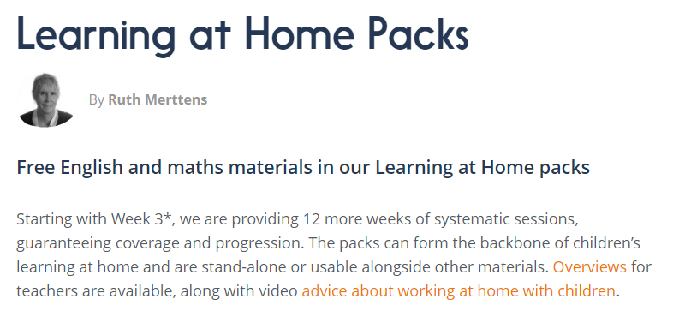
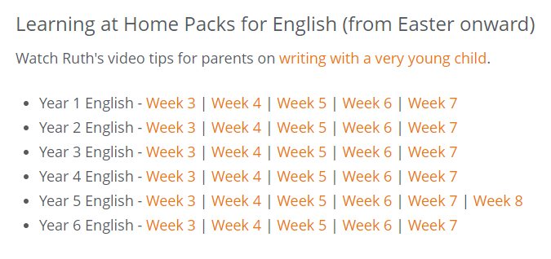

Our topic is…

Gods and Mortals

For home learning you may choose an activity from our homework grid or you might like to complete some of the following activities that we will completing in class this week.

D&T Activity

Plan which materials will be needed for a task and explain why. Make a Minotaur’s head using an inflated balloon as a base and attaching two toilet tissue rolls as a base for bull-like horns. Cover with two or more layers of papiér mâché, then use scrap materials such as egg boxes, yoghurt cartons and masking tape to create facial features. Check out a range of images and artwork of the Minotaur for inspiration. Children could also use CAD-CAM software to design and print an image of their Minotaur’s head.

Geography Activity

Describe and compare different features of human and physical geography of a place, offering explanations for the locations for some of these features. Look at and investigate the island of Crete and the Palace of Knossos using world maps. Draw a simple sketch map to show the shape of the island and use travel brochures and websites to find out why it is popular with today’s travellers. Does the Minotaur’s labyrinth (maze) really exist? Archaeologists have found no evidence that the Minotaur itself existed. However, they have found what looks like a labyrinth, many believing it to be the palace at Knossos with its many uneven rooms and corridors.

Art Activity
Use a range of artistic vocabulary to compare artworks of a particular genre or movement. Look at images of Greek plates, pots and patterns. Make sketches of scenes and patterns seen and consider if any of the images and patterns relate to the myths and legends covered during the project. Draw or paint a scene in ancient Greek style for a vase or plate based on the story of Theseus and the Minotaur. Remember to use fine brushes and appropriately coloured paints.

