SCENTED GARDEN INNOVATE

Over the past half term you have gained lots of knowledge and skills.
Now it’s your turn to work independently to show what you’ve learnt.
Choose 1 or more of the tasks below to complete. You can choose how to present it.
Show what you know about the life cycle of a plant or flower.  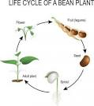 | Create something to excite your senses. This could be a perfume, potion or mixture. You could then write instruction about how you did it.  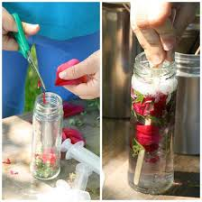
Show what you know about how flowers or plants, how they grow and what they need to ensure they grow. | Show what you know about Andy Goldsworthy or David Hockney.
Show how we can care for our planet and changes we can make to help save the planet. | Presentation Ideas  - Booklet  - Poster  - Newpaper  - Factfile  - A speech  - A picture/painting

