Year 3 Home Learning
Week of 20th April 2020

There are some wonderful ideas for home learning that can be found through BBC Bitesize:
https://www.bbc.co.uk/bitesize/articles/znbnscw
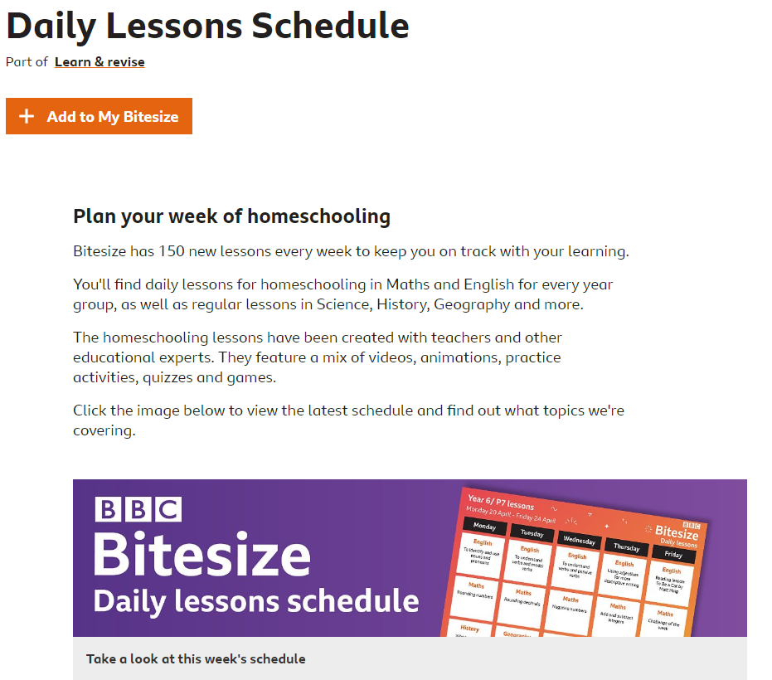
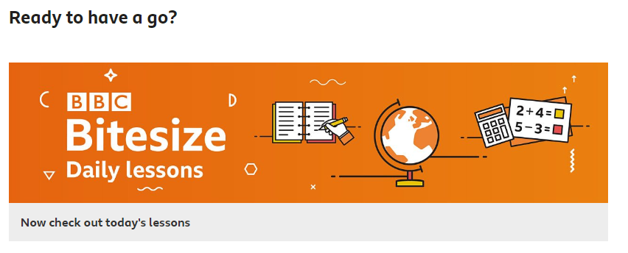

Maths
White Rose Home Learning : https://whiterosemaths.com/homelearning/year-3/.

Each day there is a short video followed by a written activity. If you are not able to print the sheets do not worry at all, you can record the answers on a piece of paper. Once you are finished you can check your answers on the resource provided.
We are now on week 2.

Activity 1
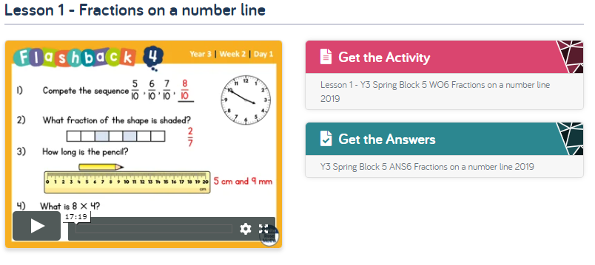

Activity 2
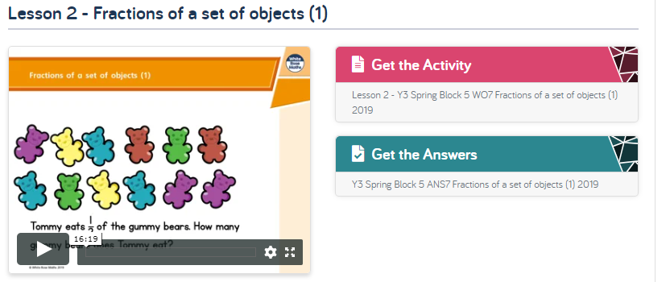

Activity 3
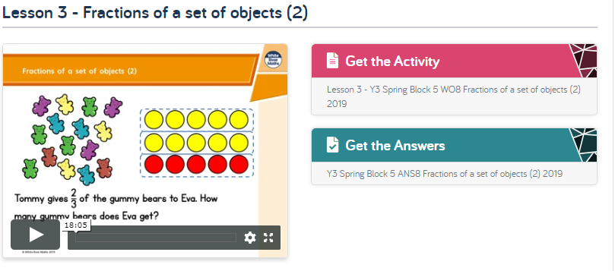

Activity 4
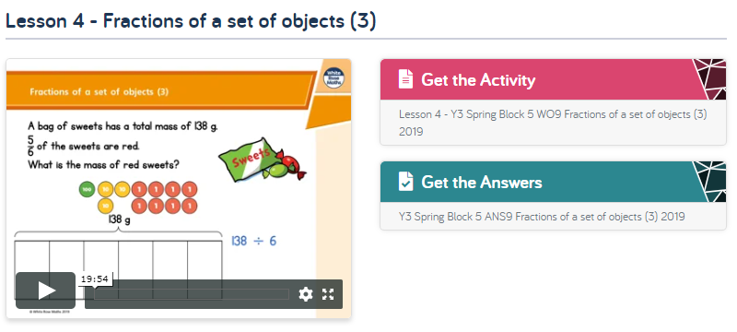

Activity 5
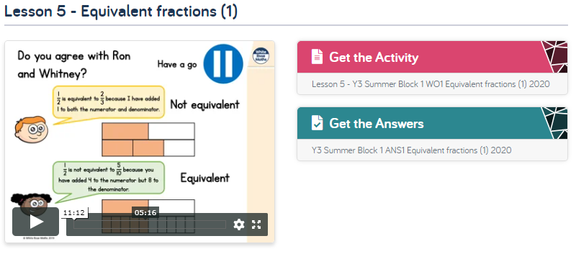

English

BBC 500 Words 2020: LKS2 Mission 500 Resource Pack
https://www.twinkl.co.uk/resource/bbc-500-words-2020-lks2-mission-500-resource-pack-t-e-2549304

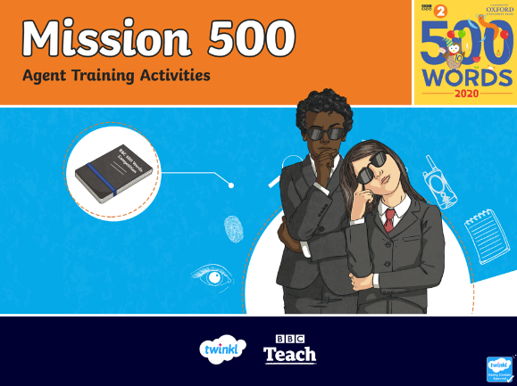
This week you can continue with the BBC 500 Words work we started last week. I would love to see the work you do, if you email me a photo of your writing or email me a copy of what you do I will email you back some feedback. This week we can work on the challenge called – What did you say? Dialogue. You can follow the slides or think about what your character and others in your story might say to one another. I will include a piece of work about punctuating speech as your grammar activity this week.

Topic Ideas

This week would be the first week of our new topic – Flow – all about rivers. I have sent out the Learning Journey for the topic as well as the topic homework grid. You can use this as topic based work over the next few weeks or you could create some work or even a topic all of your own choosing. Just have fun and keep safe.
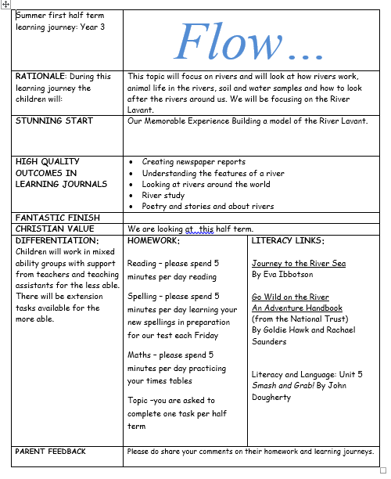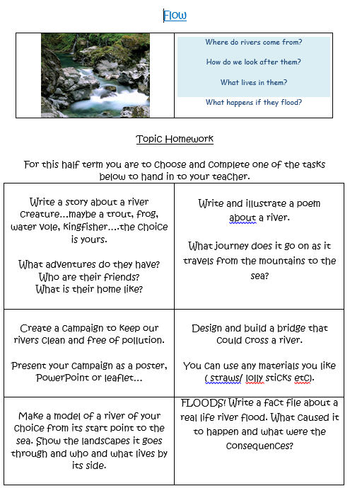
I found this DT project that could be fun…if you open the document there are instructions on how to make your very own marble run. Maybe you could even connect boxes together and put them on varying heights to create a massive marble run. I’d love to see what you create.
