Year 3 Home Learning
Week of 1st June 2020

Spellings
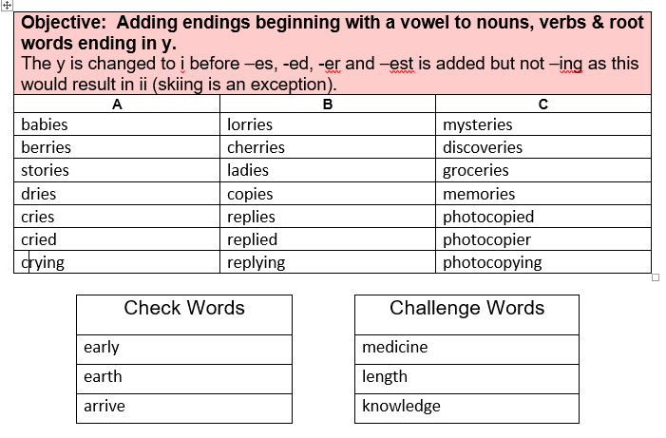

Maths
White Rose: https://whiterosemaths.com/homelearning/year-3/

White Rose Home Learning Summer Term – Week 6 (w/c 1st June)

Worksheets emailed out as attachments

Activity 1
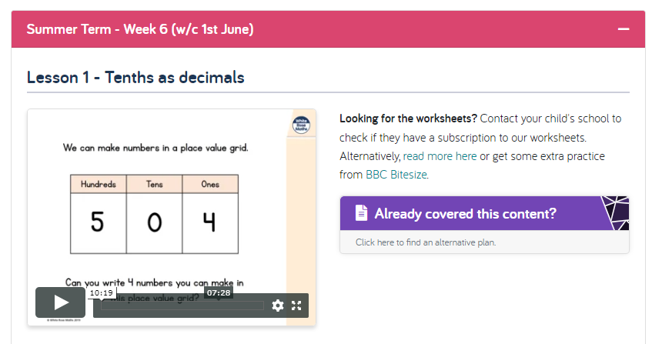

Activity 2
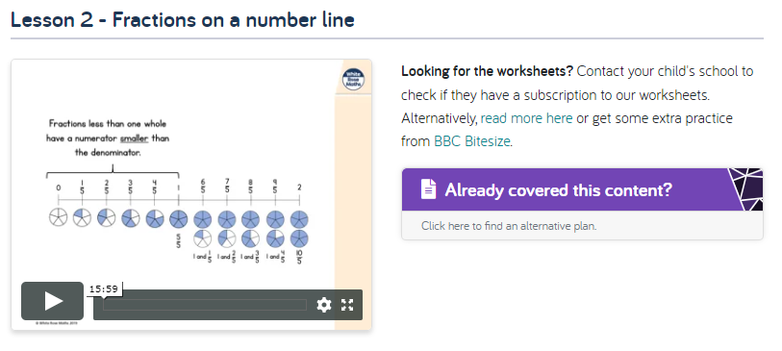
Activity 3
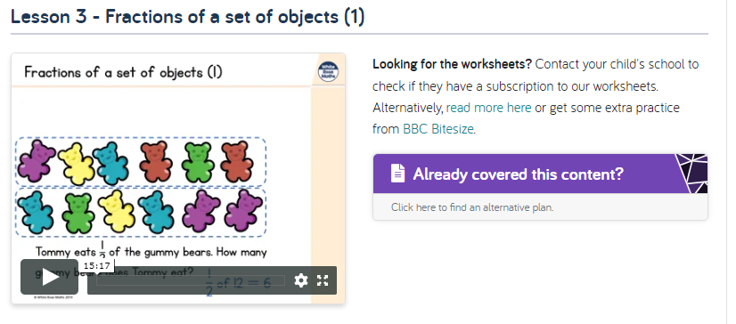

Activity 4
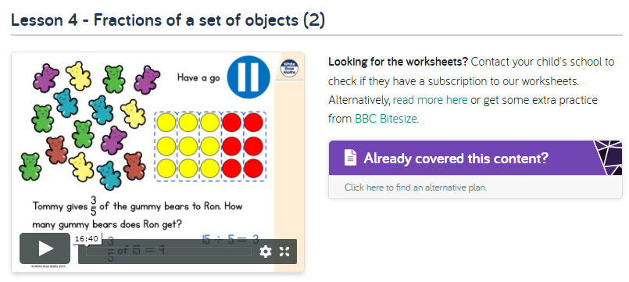

Activity 5
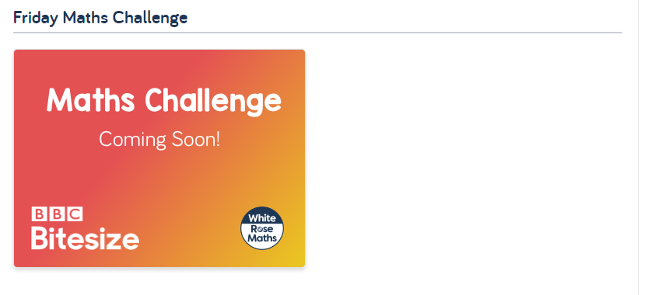

English
Hamilton Trust – Year 3 English – Week 6
https://www.hamilton-trust.org.uk/blog/learning-home-packs/
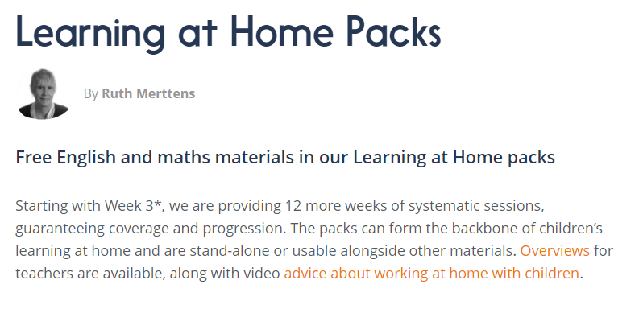
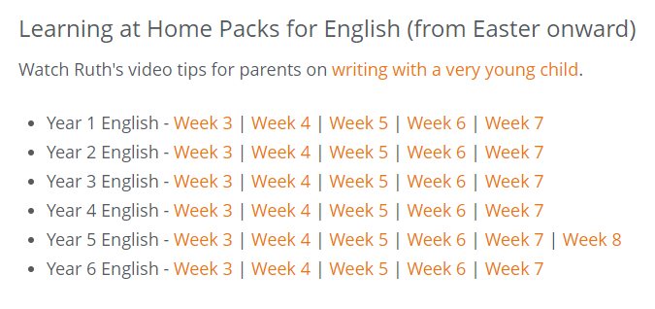

Our new topic is…

Gods and Mortals

In class this week we will launch our new topic: Gods and Mortals. For home learning you may choose an activity from our homework grid or you might like to complete some of the following activities that we will completing in class this week.

Memorable Experience

Meet Zeus (Ζεύς)… king of all the gods, ruler of the skies, cloud gatherer and master of rain. Listen to his torrid tale of how he fought and conquered his father, Cronus, then drew lots with his brothers, Poseidon and Hades, to become supreme ruler of the gods. Find out about his deadly powers and his lightning thunderbolt which he hurls at those who displease him. Hear why he carries his sceptre and his regal eagle. God of Justice and Mercy, the protector of the weak, and the punisher of the wicked… What can you discover about the mighty Zeus?

History Activity

Use appropriate historical vocabulary to describe key features of the time period.
Look at ancient Greek artefacts from a local museum and become ‘history detectives’! Look carefully at exhibitions, artefacts and museum signage and listen to experts talking about the topic. Ask questions to find out more information. Begin to collate information by drawing and note-making. Share findings collectively, comparing notes and cross-referencing information. Display findings on a learning wall or project map.

PE Activity

Demonstrate a range of throwing techniques, using accuracy and power and perform a range of jumps, sometimes with run ups. Take part in athletic activities such as running, jumping and throwing. This will please the gods! Compete against each other, perhaps taking on the roles of citizens from different states of ancient Greece. Link athletic work to further research work about the types of festivals in which the ancient Greeks would participate, such as the Olympic games, the Pythian games and the Isthmian games.

Geography Activity

Draw sketch maps and plans using agreed symbols for a key.Investigate maps of ancient Greece, noting how the country was once divided into a collection of smaller city-states. Make a simple sketch map to show the states of ancient Greece including important geographical features such as islands, seas and mountains. Tell the story of the war between the two states of Sparta and Athens, highlighting their differences and explaining the reasons for the war.

